**SAGA Design Pattern**

[Axon Saga to Query Another Microservice](https://stackoverflow.com/questions/66925699/axon-saga-to-query-another-microservice)

When a @SagaEventHandler needs to fetch data from another Microservice that also uses Axon Framework, is it a good practice to use QueryGateway to query another Microservice? Or it is better to use something like RestTemplate to call another Microservice from a @SagaEventHandler method?

In my opinion, you can go any way as both of them have pros and cons.

But, since you are already using Axon, I would go with that because of the benefits of location transparency and all the types of queries you get by granted from AxonFramework (point-to-point, scatter gather and subscription query).

Bear in mind that, when using "components" on the Saga, make them transient to not have them serializable.

One thing u should remember whenever u are creating any command or any event u should must handle that particular commands and events.

--------------------------------------------------------------------------------------------------------------------------------------------

First let’s understand What is Saga design pattern and why we need a Saga design pattern.

The Saga Design Pattern is a way to manage Data consistency across microservices in a distributed transaction scenario.

What is a distributed transaction scenario?

Firstly, we need to understand what is Monolithic Architecture and what is Microservices Architecture?

The Transaction which is been started in a Monolithic application will be single. Bcz considering one example if u are placing one order. So, when you are placing an order, you will be adding a product, you will be adding a data to the order table then you will be performing a payment you will validate the payments once payment is done you will ship the particular products. You will add the entry for shipping and then you will complete that particular order. So, all those things will be completed in one single transaction in a monolithic architecture.

But when it comes to Microservice Architecture its not the case. Because for every different thing will be having a different service. Like for order there will be a different service, for handling payment there will be a different service for handling shipping there will be a different services and when you are doing the same example placing the order then your transaction would be start at the Order Services where you will be starting your order, you will be adding your products to the shipping cart and after that that particular order will call your payment services and from that particular payment services once the payment is successful it will call the shipment services to add your data in your shipment table and after that once a shipment is completed it will again call the your order services to complete your order.so you can see that your particular transaction is span across the different microservices. So, to handle that particular scenario that your particular transaction is been across the different microservices i.e the distributed transaction right. Because your transaction is not at a one place it has to be handled from the multiple places.

Suppose taking a same example when you start the order you started the order you added your data in your order table like this many products will be added to your order after that you go for a payment right?? Suppose there is any issue in a payment services and your payment was not successful. So, what should happen is you should not be saving any data for that particular payment as well and whatever you did for order as well bcz that particular thing also should be neglected.

So, there are multiple way’s can be handled and there is a one way that is a Saga Pattern. In saga also there are 2 things **Choreography Pattern** and **Orchestration Pattern**. In this tutorial we will learn more about the Saga Orchestrator. It’s simple thing when you have a transaction that span across the multiple services and how to handle that particular transaction will be using any of the design pattern of the microservices to handle those transaction.

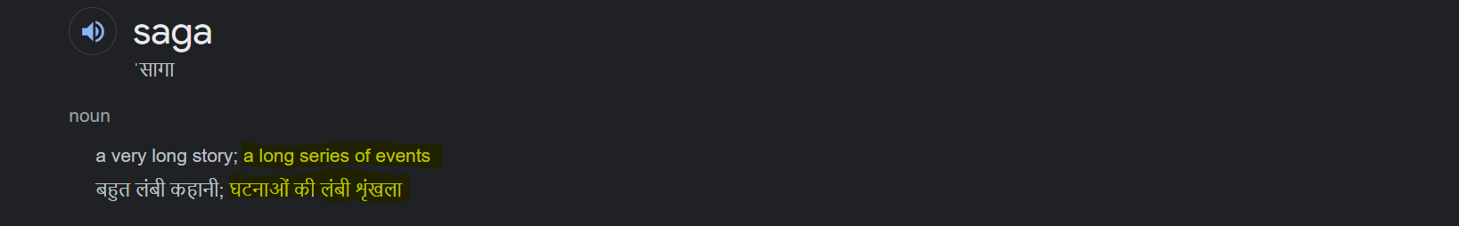

**Order Sagar -**

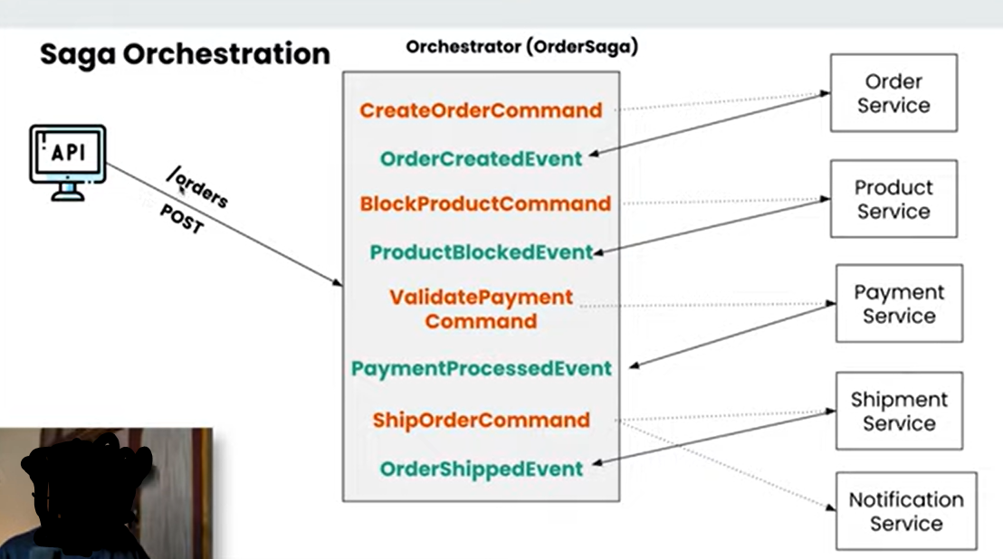

So, let’s understand the Saga Orchestration. So here you can see that we have an API that is **POST** request that is doing the **/orders**. So, we are placing the order over here. In this Saga Orchestration pattern there would be one Orchestrator that will handle your entire saga that will handle everything that is been happening in your application.

So, I am placing one order so that is one scenario. So, everything related to that particular order all the steps included in that will be handled by one orchestrator that I have defined here as an **OrderSaga**. So, this particular things in the microservices we are implementing using the **event-driven-architecture**.

**---------------------------------------- Brief about the Event- Driven- Architecture-------------------------------------**

We will be creating events and commands for every operation that we are going to perform.

Let me take you to the Event Sourcing page…

Event Sourcing is a way of storing an application’s state through the history of events that have happened in the past. The current state is reconstructed based on the full history of events, where each event represents a change or fact in our application. Events give us a single source of truth about what happened in our application. It is especially beneficial in applications that need to provide a full audit log to external reviewers. The current state is called **Materialized state** in some resources. The following figure represents the reconstruction of materialized state based on the history of events.

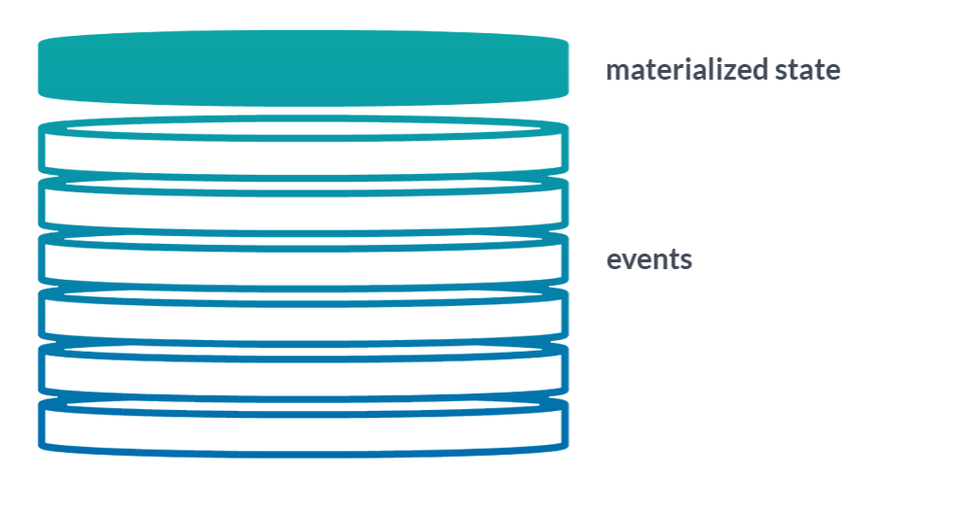

So, AXON Server using this Event Sourcing technique to store all of the particular events.

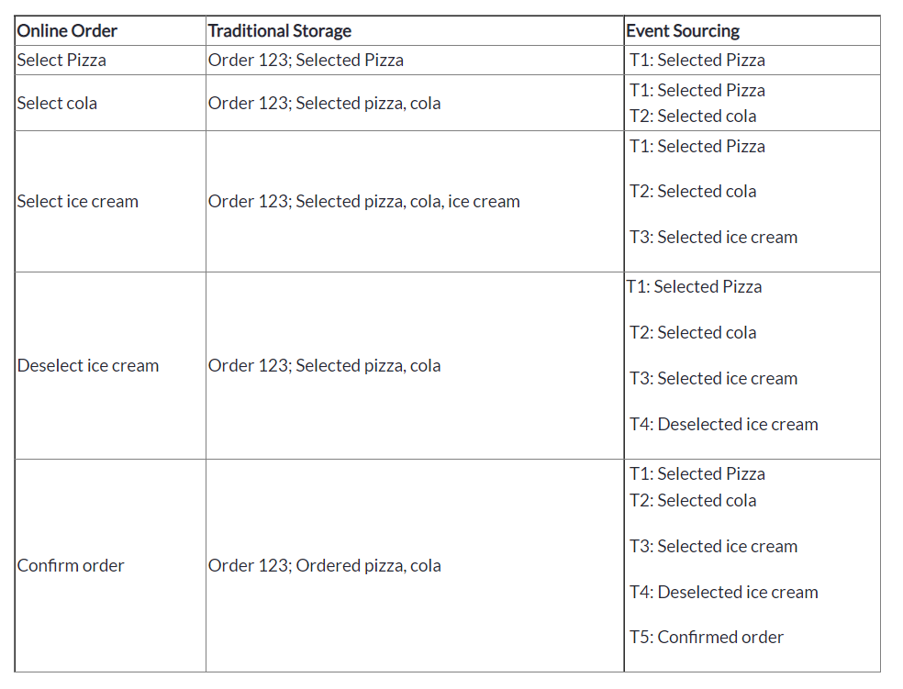

So, here lots of events is happening. All these particular events like selecting the pizza, selecting the cola then selecting the ice-cream and then de-selecting the ice-cream and then performing the order. all these particular events that are happening are stored inside the **Event Data Store** and all these particular events at the ends will result in a single data that has been read by the **Read Database**. all these particular events executed and results in a single order over here and that single order will be store in a database over here.

Why this particular event-sourcing is so helpful is whenever you have an issue, or you want to re-create the same order you can play the entire this particular event source from start to end to create the same data that you want. You can always go and do select a pizza, select a cola, select an ice-cream and de-select an ice-cream and order it. So, in that way you were able to re-create the same order multiple times for our debugging purposes or you want to create a new database lot of things u can do using the event-sourcing. You can do the snapshots and event Replaying as well.

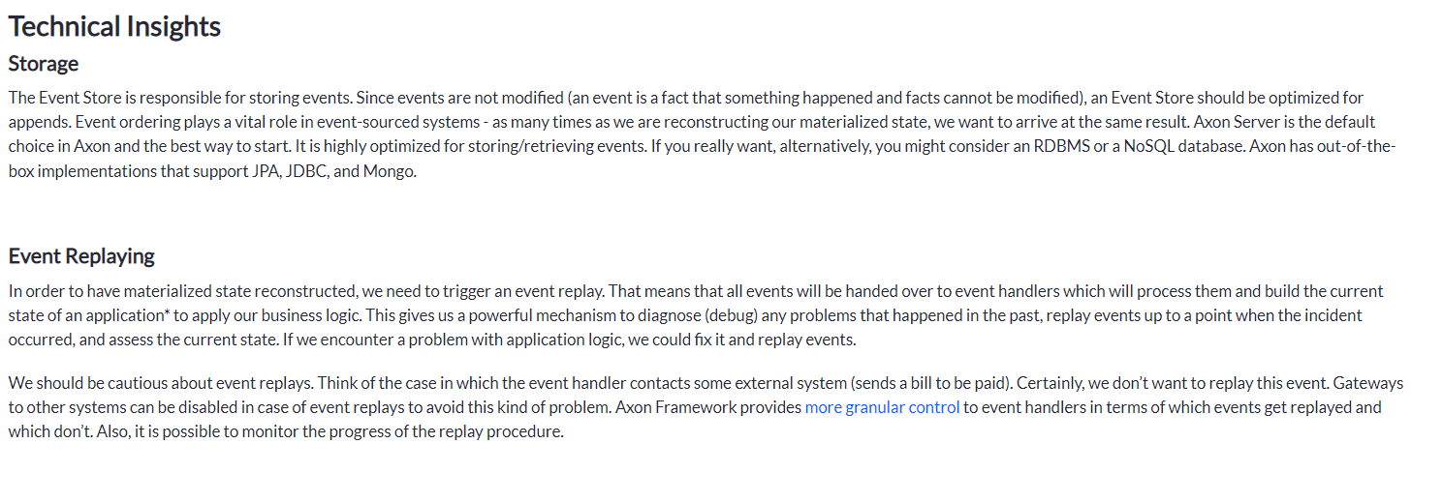

So, these all are the key concepts using by the axon framework and we are also using the axon server so axon server will be responsible for the storing all those particular details and you will be using axon framework along side with the springboot to handle all particular operations. So, this is all about the axon server, axon framework and how we are going to store the data.

------------------------------------------------------------------------------------------------------------------------------------------

let’s come back to the Saga Orchestrator. So here you can see that there are different services available. So, these all are the different microservices that is **Order Service, Product Service, Payment Service, Shipment Service** and **Notification Service** and all.

Below one is our **Orchestrator** that will handle all particular services and which particular services to be called for the different operations. So, when you place a particular order at that particular time the Orchestrator is creating a command like **CreateOrderCommand** that means it is giving a command like I got the request to create the order and I am giving you the order to create the order so, this is particular **CreateOrderCommand**. So, **CreateOrderCommand** will be consumed by the **Order Service.**



This particular **OrderService** will have the **CommandHandler** for that particular order. From that particular **CommandHandler** this particular command will be handled and at that particular time all the validations and all the other things will be performed and after that once the particular validation and other things performed that particular order service will create the event. so, that particular event will be **OrderCreatedEvent**. At that particular time **OrderCreatedEvent** will be consumed by **OrderSaga** as well plus you **OrderService** as well. So, both the things will consume that particular event. What **OrderService** will do, **OrderService** will store that particular order and it will say that I got the order. So, that particular data will be store to database for order service and this particular event “**OrderCreatedEvent**” will be consumed by the **OrderSaga** and this particular **OrderSaga** will know that ok I got this particular event that means the order detail has been stored in the database. now after that I need to lock that particular product. Bcz suppose that I have the quantity of 5 in my stock and when one particular order has been done, I need to block that particular order. So, it will create a new command to block that particular product. This particular “**BlockProductCommand**” command will be consumed by the **ProductService**. and that particular **ProductService** will be remove that particular quantity from that product table and then it will create a new event called “**ProductBlockedEvent**” so, **OrderSaga** will get to know ok this product is also blocked now. now let’s go to the next step that is the **To Validate the Payments.** So, **OrderSaga** will create a new command that is **ValidatePaymentCommand** so this **ValidatePaymentCommand** will be consumed by **PaymentService**. This **PaymentService** again in return create an event that is **PaymentProcessedEvent** again this event **PaymentProcessedEvent** will be consumed by both the services **OrderSaga** and **PaymentService** both**. PaymentService** again perform the payment processing and store the details into database. and **OrderSaga** once consumed this particular **PaymentProcessedEvent** it will go to the next steps to give the next command that is to **ShipOrderCommand**. So, it will create a **ShipOrderCommand** and that particular **ShipOrderCommand** will be consumed and will be handled by the **ShipmentService** and this particular **ShipmentService** will create the particular event that is **OrderShippedEvent** and this particular **ShipOrderCommand** will be consumed by the **NotificationService** as well.so, **NotificationService** what it will do is it will also consume that particular event and it will notify the user that we got your order, and we will ship that particular order. And at that particular end (--**OrderShippedEvent--)** like order is shipped now and at that particular time entire saga will be completed. So, until and unless that entire saga is been completed your order won’t be processed. If there is any error that particular entire transaction can be revoke. So, this is the happy scenario now let’s understand how the **transaction** are---



**Saga Transaction**

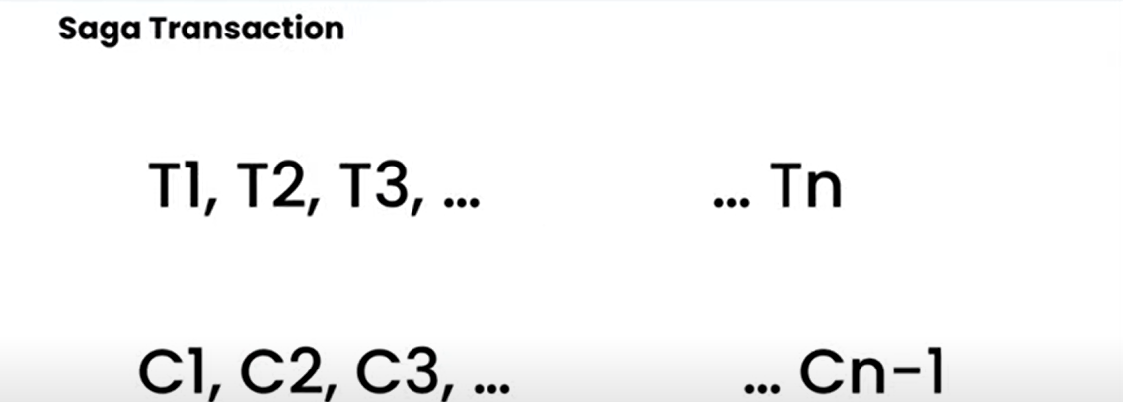

So, we can see that the saga transaction will be defined in this way. There will be multiple transactions available and as it is span across the different microservices you don’t have that ability to revoke that particular transaction. So, for all the transaction you do in all the different microservices in that particular project you have to have the compensating transaction to perform the revoking operation.







So, suppose you created the order and after that you created the payment and your particular payment service failed so at that time you have to have the compensating transaction for your order as well. That order whatever that stored has to be cancelled. So here you can see T1, T2, T3……upto Tn and the compensating transaction should be C1, C, C3 ……upto Cn-1. Now if you have gone upto the 3rd steps like T1, T2 and T3 and some thing happens at this particular point then at this particular point you should be having the 2 compensating transaction because you are at the 3rd place that should be C(3-1) and C(3-2) i.e C2 and C1. Just remember that there would be transaction and there would be compensating transaction for that because we can’t handle the atomicity directly in microservices.

**Workflow to Build Application + Transactions + Compensating Transaction**

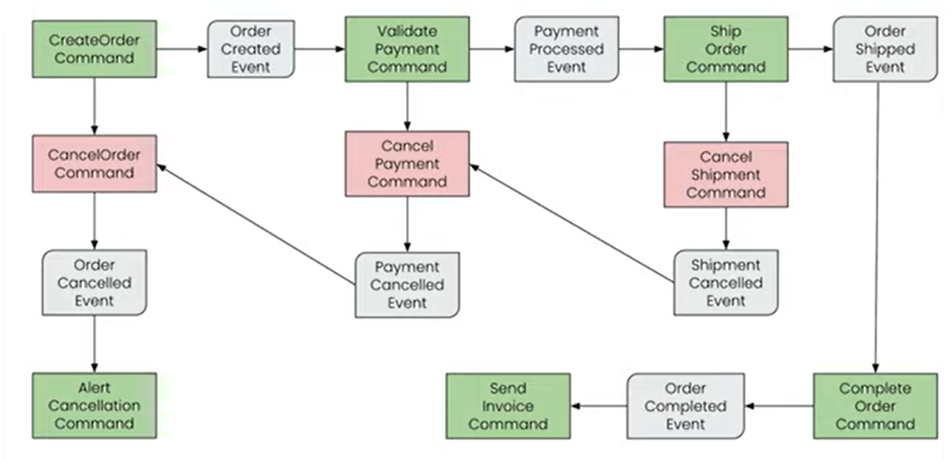

So here we can see that whenever our particular API will be called there will be a **Controller** that controller will handle the API Request that is **POST** for the create order and it will create one particular **Command** **CreateOrderCommand** my **OrderSaga** this is everything about my **OrderSaga**. So, this particular OrderSaga will have one command that is **CreateOrderCommand.** So, once I have the particular command there will be always 2 scenarios right there will be a positive scenario and there will be a negative scenario, success, and failure so we will see both.

So, when there is a success from that particular command, at that time we will create the **OrderCreatedEvent**. So, for every command we will be creating the event. So, once the particular command is successful, we will create the Event for it and if it’s not successful we will be creating the compensating event for it. So, this is a **CreateOrderCommand** and if that is successful **OrderCreatedEvent** will be created and if it’s not successful we will create the **CancelOrderCommand** over here to cancel the particular order and that particular **CancelOrderCommand** will create the OrderCancelledEvent to cancel the particular order. Now if the scenario is successful and there is no issue in creating the order after that we will create the new command that is the **ValidatePaymentCommand** to validate my payment for whatever the order we have got. And for that if every validation and everything is successful, we will create the event that is called **PaymentProcessedEvent** and if it was a failure scenario, we will create a command that is **CancelPaymentCommand** and this particular **CancelPaymentCommand** will create the event that is called **PaymentCancelledEvent**.

Now this particular **PaymentCancelledEvent** should call the **CancelOrderCommand** as well. Because we need to have the compensating transaction for everything. So, once my payment is cancelled, we need to cancel the order as well. So this particular **PaymentCancelledEvent** will again call the **CreateOrderCommand** that will cancel the order for me. Let’s come to the positive scenario I have create the **PaymentProcessedEvent** when payment validation was successful. After that we will create a new command that is **ShipOrderCommand**. Now my payment is successful now let’s ship that particular product and, in that scenario, as well if its successful we will create a new event that is **OrderShippedEvent** and if it’s not successful we will create the new command that is **CancelShipmentCommand** that again will create an event that is **ShipmentCancelledEvent**. So, there is an issue in my shipment right so that shipment should again cancel my payment as well so here you can see that **ShipmentCancelledEvent** again calling the **CancelPaymentCommand** that will again call the **PaymentCancelledEvent** that will result in the cancellation of the order. So, here you can see that there will be a chain of commands that will be executed.

Now let’s get back to the success scenario. My **ShipOrderCommand** was successful and that resulted in the **OrderShippedEvent** so that particular **OrderShippedEvent** will result in the **CompleteOrderCommand** that means my order will be completed at that particular time my Saga should also be completed. So, here you can see that **CompleteOrderCommand** is successful it will result in the **OrderCompletedEvent** and once the **OrderCompletedEvent** it can send the command like **SendInvoiceCommand** to send the invoice and when the **OrderCancelledEvent** was executed at that time we also need to notify the user like your cancellation was done for your particular order because of this particular issues so, at that time we will also send the **AlertCancellationCommand** to the system to send the particular cancellation to the user. So here you can see that we have the success scenarios, and we have the failure scenarios as well and you can see everything is linked together. So, for every point of time wherever you are we will be creating the compensating transaction for it.



We will create all the different services over here. I mean all the different spring boot application. So, I have mentioned: -

* **Order Service**
* **Product Service**
* **Payment Service**
* **Shipment Service**
* **Notification Service**

All the different spring boot application we will use the **axon framework**.

**Application Name**: OrderService

**Dependencies**: Spring Web, Lombok (to create all boiler plate code), Spring Data JPA, H2 Database

* So, once we download this project, we are adding our Axon Framework dependencies as well.

Mean while just download the **axon server**.

To download AXON Server please go to the below link--🡪

<https://developer.axoniq.io/download>

download AXON Server zip folder…

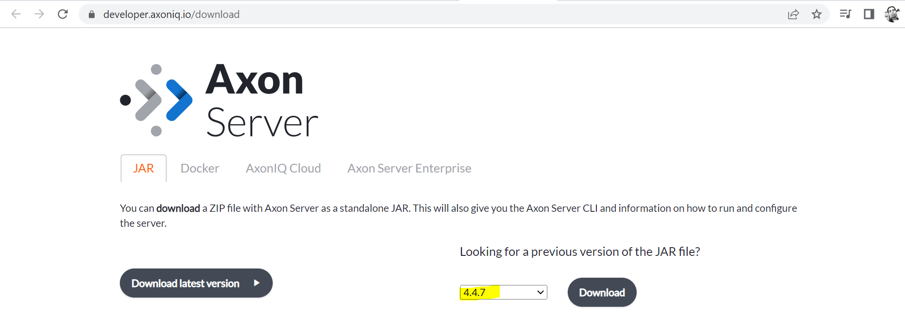

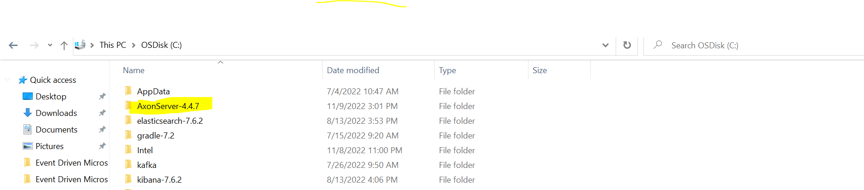

Let’s start the axon server—

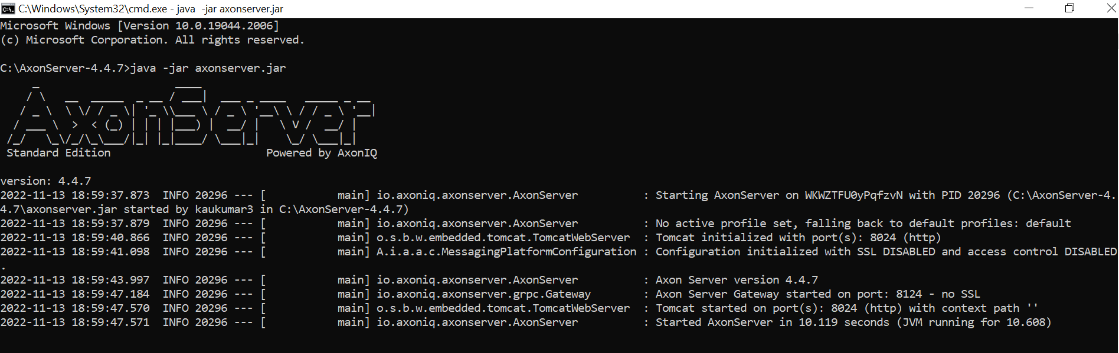

And it’s running on port **8024**

<http://localhost:8024/>

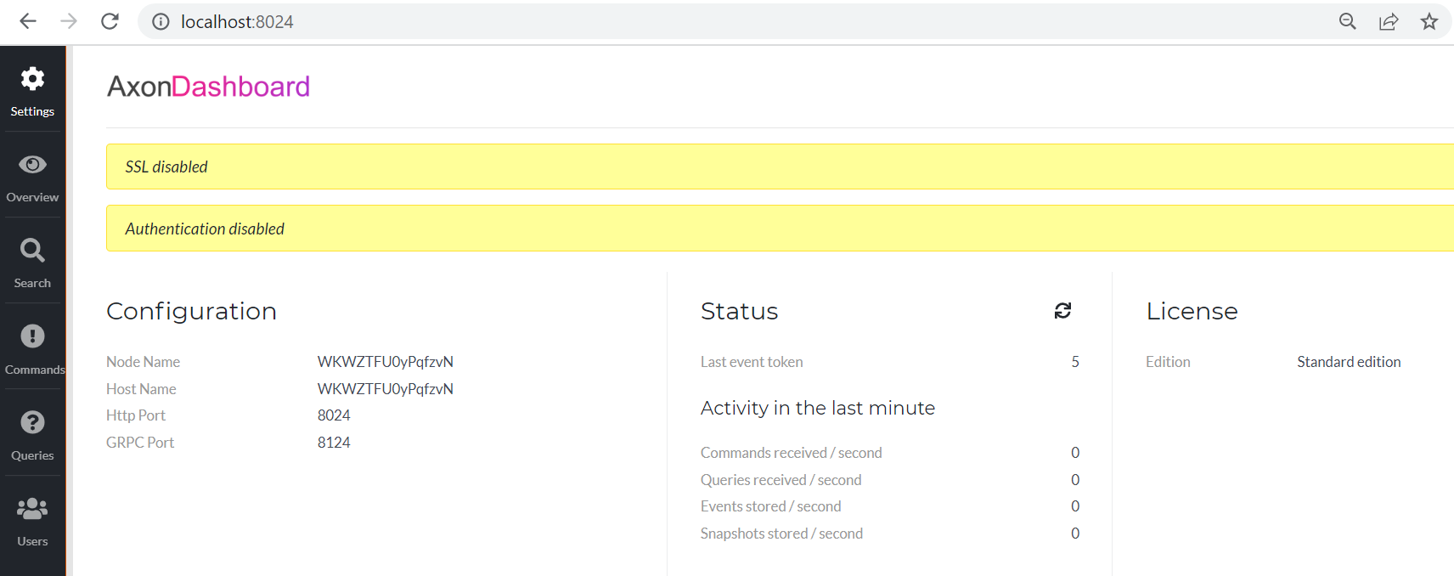

This is our axon server dashboard.

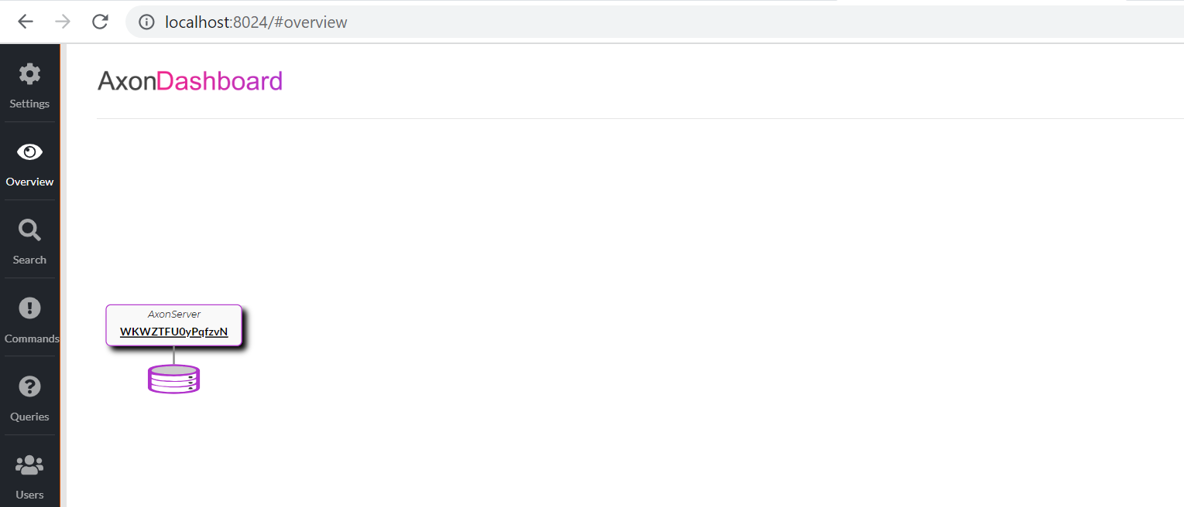

There is no application connected to it.

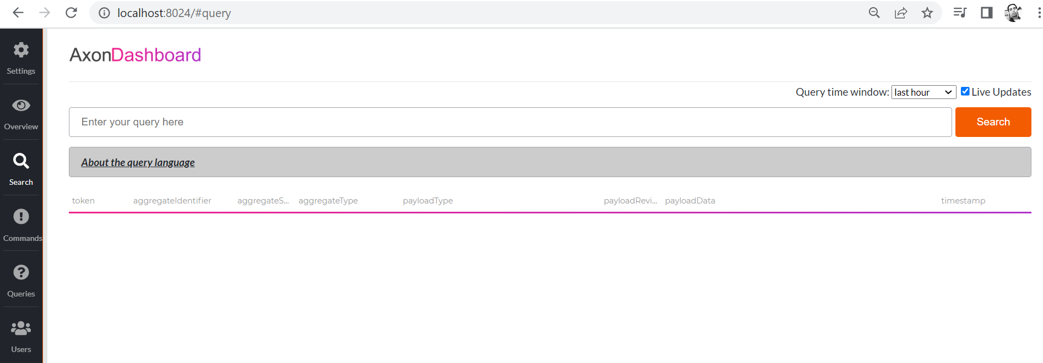

You can search all the events which occurred. So, I enable live updates over here.

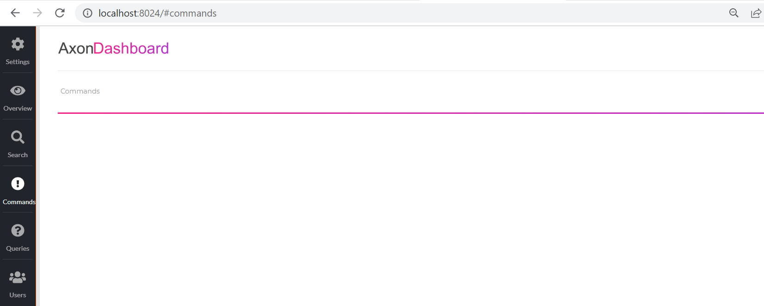

What are the different commands you can see over here.

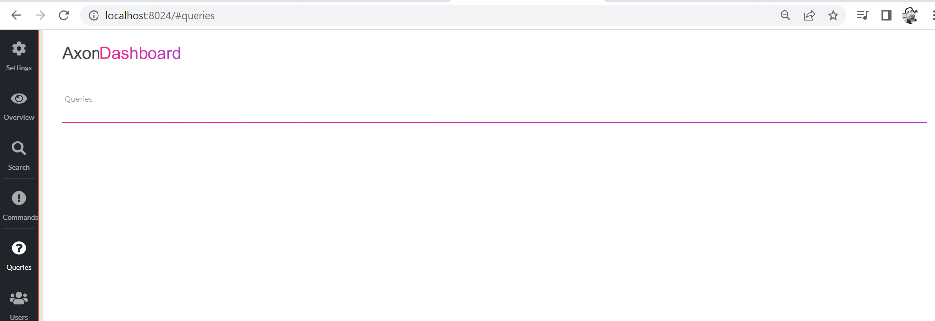

What are the different queries you can see over here.

So, we are using CQRS pattern along side SAGA so, it will be helpful for u if u have seen a previous video, it will help u a lot in this particular video. So, this is the axon server for you.

So, let’s go to the dependencies and add the axon framework and dependencies for it.

**So, here we need to add the Axon Framework.**

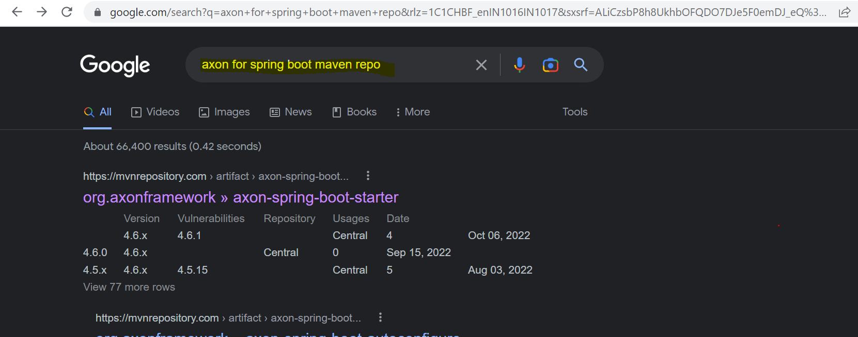

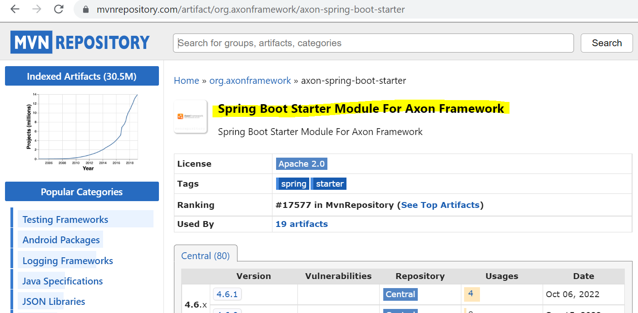

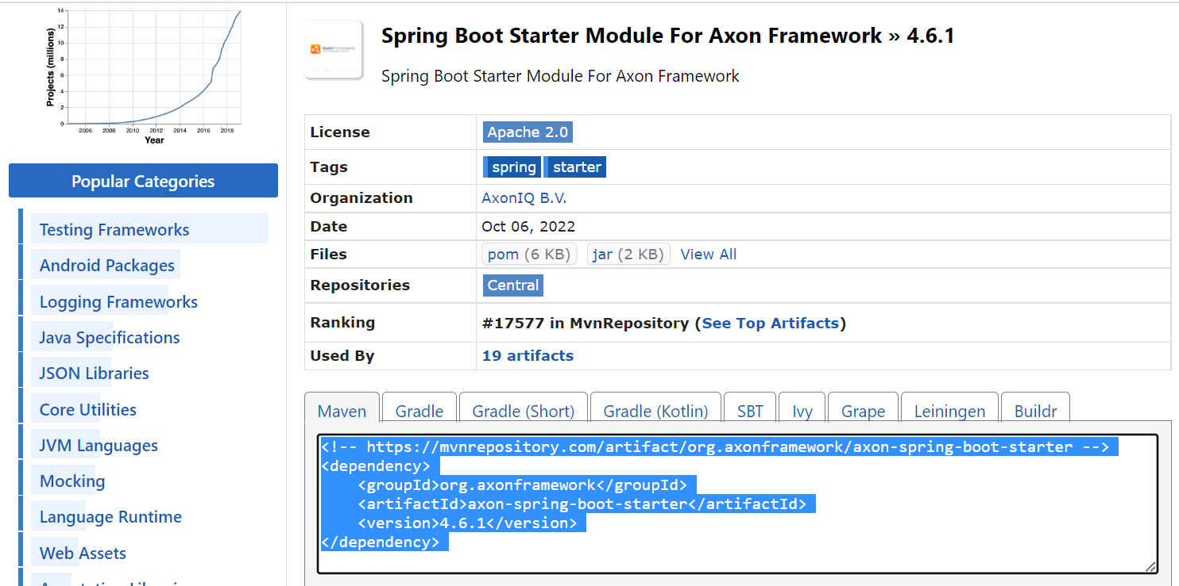

And this particular AXON Framework also needs the Google’s Guava dependencies as well.

So, let me add that as well

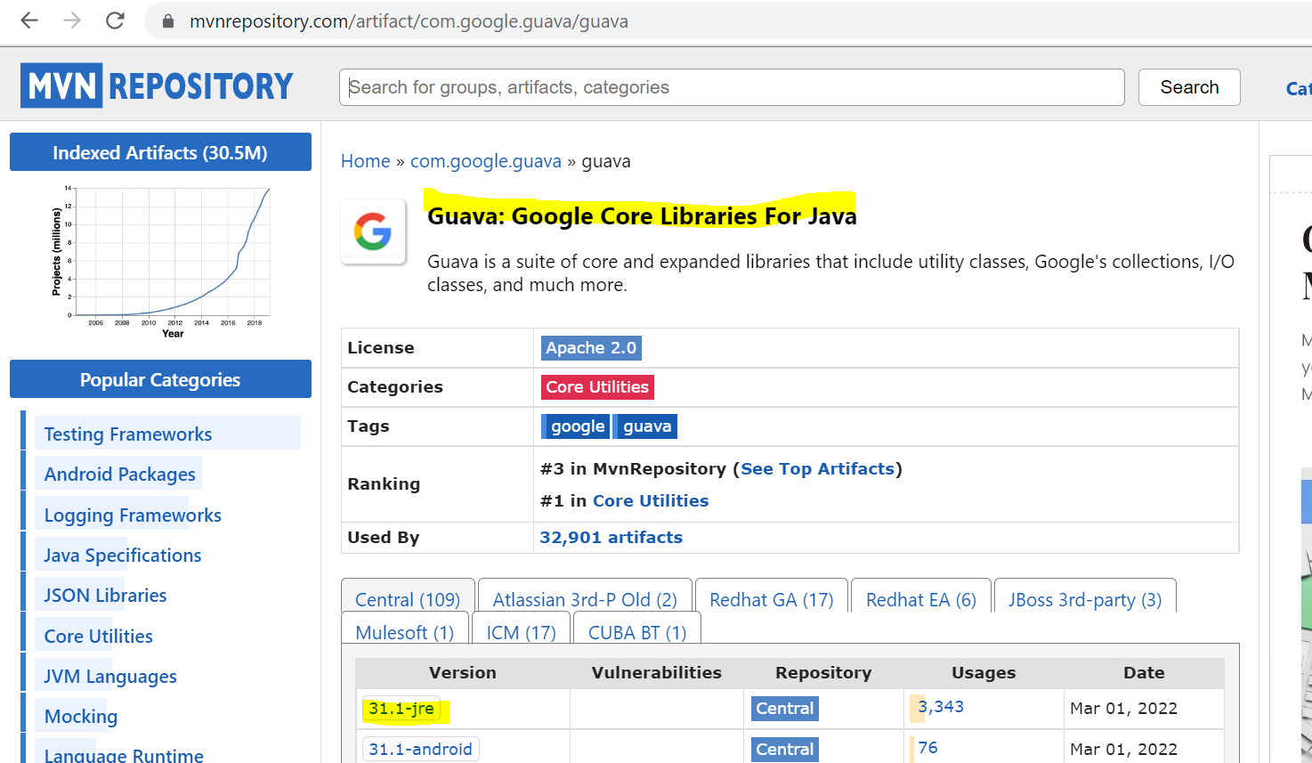

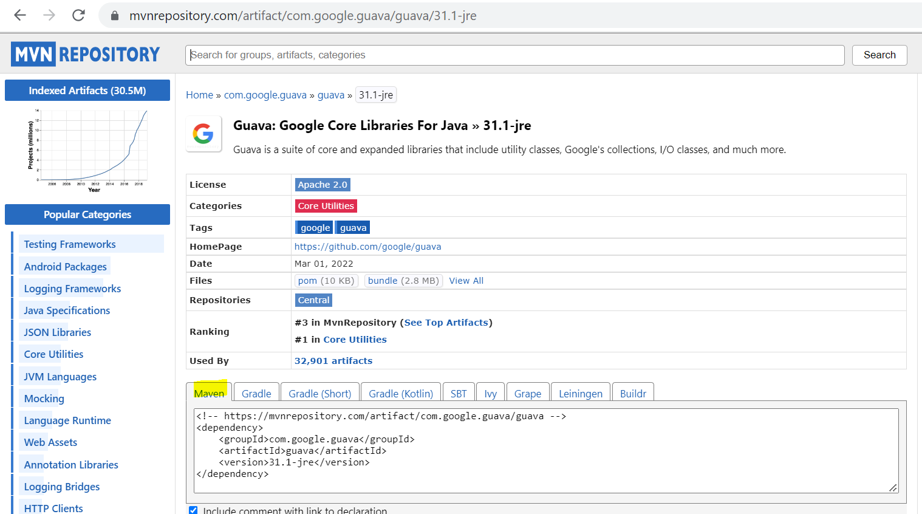

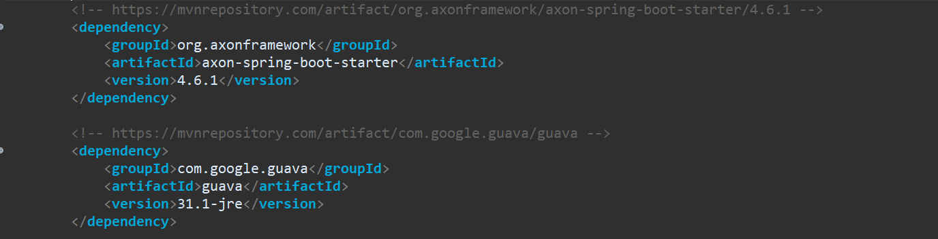

So, these are the 2 dependencies you need to add in your application. As we have added in OrderService let’s create other services and add to them as well.

Application Name: UserService

Dependencies: Spring Web, Lombok (to create all boiler plate code), Spring Data JPA, H2 Database

Application Name: PayemntService

Dependencies: Spring Web, Lombok (to create all boiler plate code), Spring Data JPA, H2 Database

Application Name: ShipmentService

Dependencies: Spring Web, Lombok (to create all boiler plate code), Spring Data JPA, H2 Database

Now, one thing is as we are having the multiple services there might be some files some classes you will be creating that will be using in multiple services so for those particular things, we are creating one common service and the dependencies for that will add in every resource every service that we have so, there will be no duplication of files. So, for that let me create the common service.

Application Name: CommonService

Dependencies: ~~Spring Web,~~ Lombok (to create all boiler plate code)~~, Spring Data JPA, H2 Database~~

So, all the common files and common classes we will keep here, and we will add the dependencies in all the projects. So, in this common service I don’t need H2 database, Spring data JPA and Spring Web. Just the Lombok dependency to add the getter setter and boiler plate codes.

Now let’s add all the services in STS and add the axon framework dependencies in all the services.

In CommonService I don’t need the main method and let me copy the **group-id, artifact-id,** and **version-id** from CommonService and let me add this common dependencies in all other services.

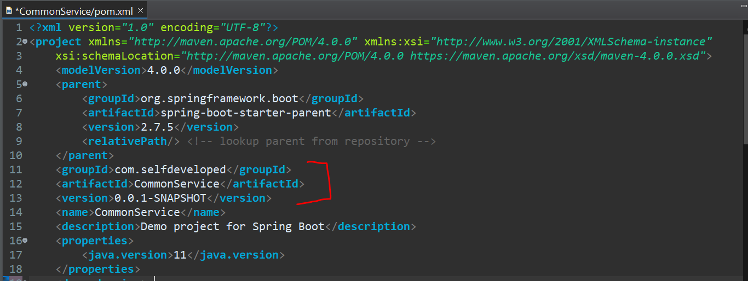

We need to copy **group-id, artifact-id,** and **version-id** from CommonService and let me add this common dependencies in all other services.

As we have added common dependencies in Order Service below…. same we need to do for all other service as well.

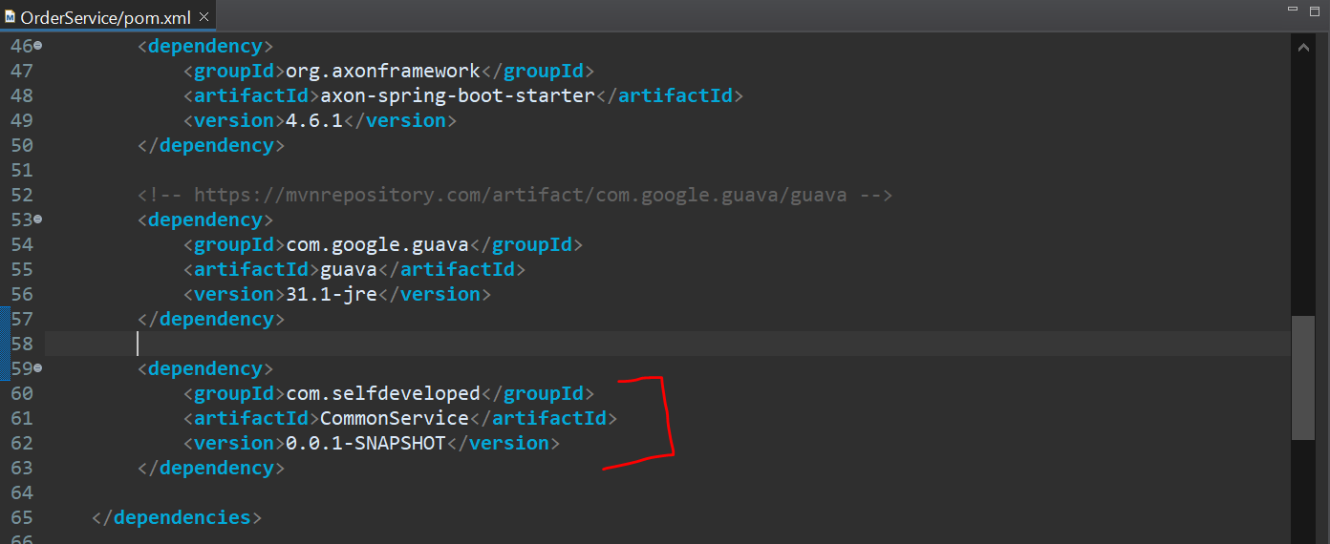

Now my all the configuration are done now. Now we need to configure the database as well and the server port. All these microservices will be running in to the different ports and all those particular microservices will be having their own database. as we are using H2 database I will be using the file database over here. you can use the MySQL as well there won’t be any change. So, let me go and add all these particular details as well.

Let me add first in **application. properties** file in OrderService Application—

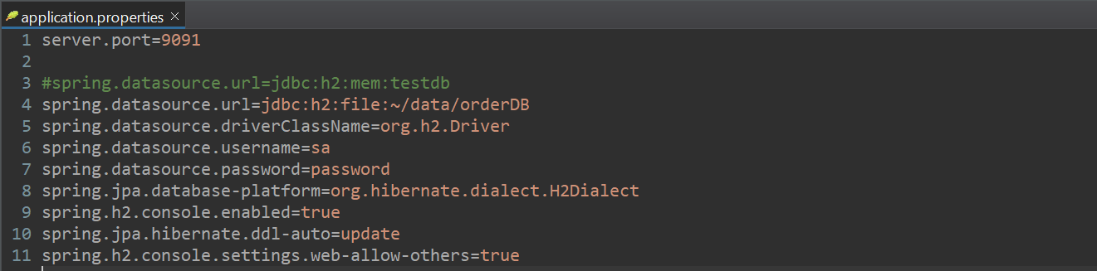

So, my OrderService will be running on port **9091.** I am using the h2 file over here and this is **~/data/orderDB** (slash data slash orderDB) so, in my data folder in my local orderDB file orderDB database will be created and driver class name as I am providing h2.Driver bcz I am using the h2 database. I have enabled the h2 console over here, so I am going to the h2 console from the browser. So these are the same setting we are going to add in all the applications.

So, let’s go and do that…

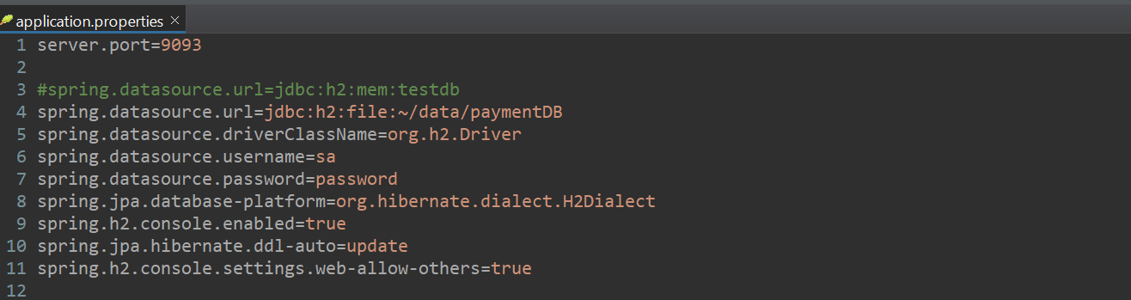

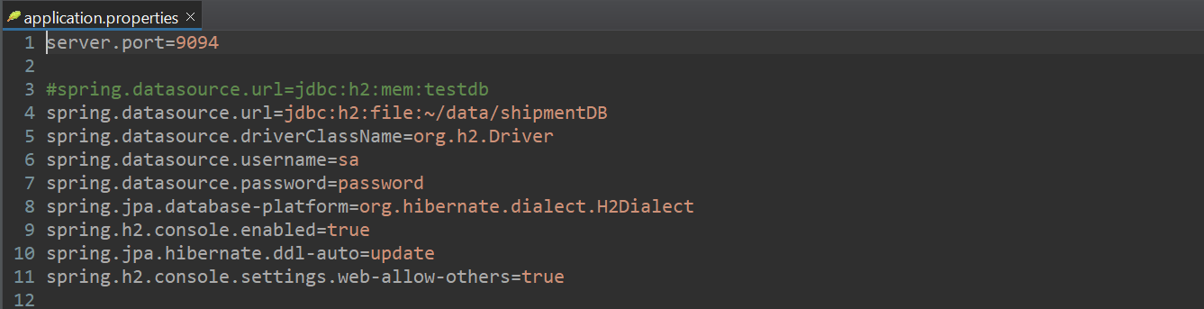

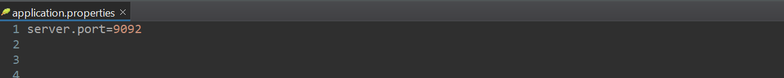

In UserService I have just added the port **9092** I have not added the database configuration. So, from this particular UserService for now I am just planning to pass the static information so I am not adding the database for now, but u can go and add the db details and u can get the details from the database to pass on.

So, in our **OrderService** let’s create a different package and let’s start our implementation-

So, In **OrderService** application we created a package name called **command.api** so, all the different command will be added in the command.api package. I will also create the **query.api** to add the different types of queries. Command and the Query are the things which you can learn in the **CQRS**.

In **command.api** package let’s create another package **controller** and **model**. Let’s create controller class called **OrderCommandController**, so this controller will handle the **POST** request for handle the order. And whenever u are creating one order, we are creating one json body over here. like what will be an order detail, order id and order price something. So, for that let’s create a model for it and let’s inject it over here. so, in model package let’s create a model called **OrderRestModel**.

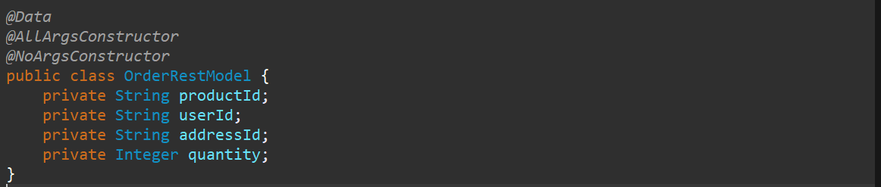

**userId** shows for which user order belongs to. **addressId** to which particular address I need to send this. **quantity** shows how many quantity of this particular product I need to send.

Now, Inject this **OrderRestModel** in my **OrderCommandController**.

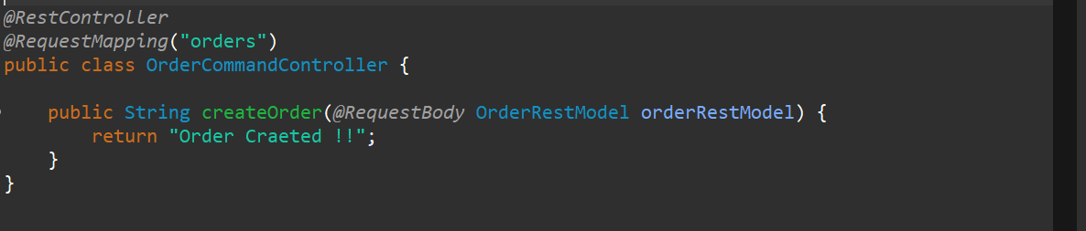

So, now from here what we need to do is we need to create the **commands** and we need to create the **events** to handle these particular things.so, if u go to the particular slide over here, we have created the different commands and we have created the different events to handle those particular things.



And if u want to understand the flow

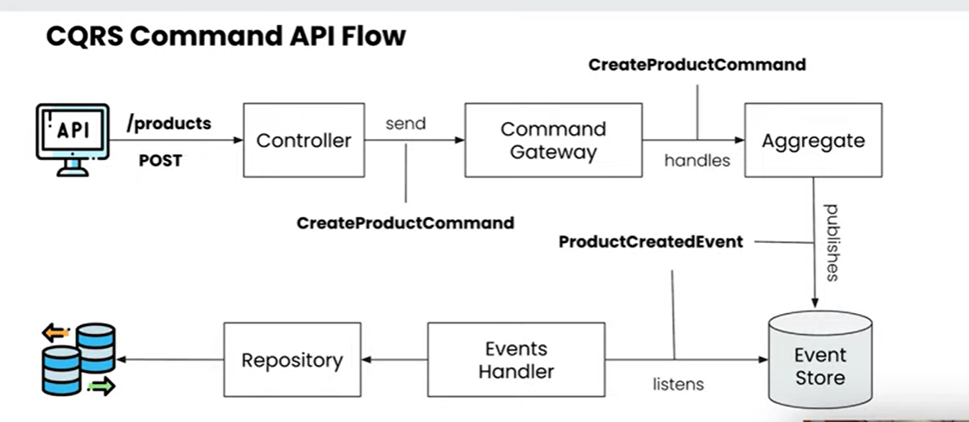

Here we are doing **CreateOrderCommand**. We can also call the CommandHandler as an **Aggregate**. So, this **Aggregate** will handle the particular command **CreateOrderCommand.** It will handle the particular command and it will handle the event **OrderCreatedEvent** and all those particular events will be stored into **EventStore** and there would be one **EventHandler** which will handle those particular events and it will save data to the **Repository**.

But in our **saga design pattern** there will be one more **Saga** that will be handling an **event** and based on the event it will call the other **command** as well.



So, here you can see once the particular event is created so that particular event is been handled by this particular **OrderSaga** and it will be processed by the different services that we have.



In this particular slide u can see that we will be creating **CreateOrderCommand** over here and **OrderCreatedEvent** over here and this will be handled by the **Saga** as well plus my **OrderService** as well. So, let’s go and do that… so let’s a **command** package in **command.api**. and as we discussed in earlier video all the commands and all the events we create over here. all the particular classes all the particular objects should hold the data over here. so, whatever the data we are sending from controller it should hold all the particular data then only at the end it will be able to receive all the data and update all the particular data.

So, whatever the payload right. As this is a command and this command should have a payload like what data and what I need to process so, we are adding all of these particular properties we want to store, and we will set all of those particular properties. So go to OrderRestModel and copy all of those properties plus I need orderId as well.

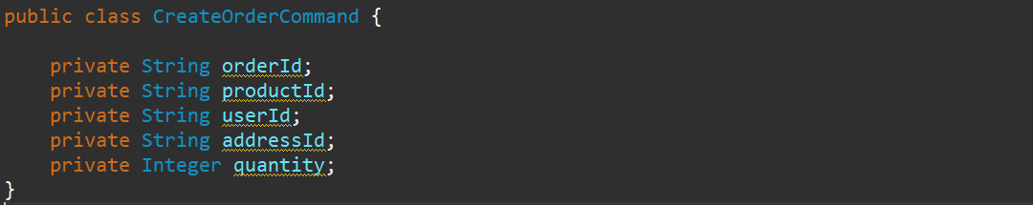

Now for all the commands and all the handler that we create it has to have a unique identifier. So, here orderId is the unique key. So, I need to annotate with @**TragetAggregateIdentifier**. So, this particular id will be handled by the **Aggregate**. So, Aggregate will be able to understand the difference between different orders that it has to processed.

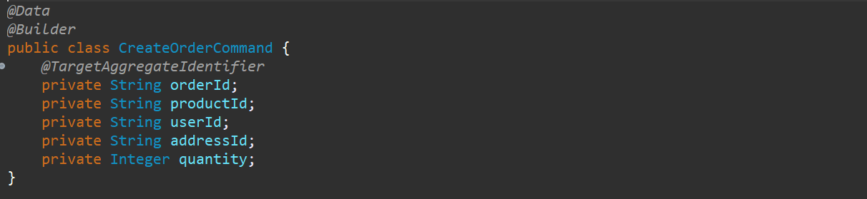

We are using @**Builder** annotation so we can use Builder pattern to populate all the fields. Now the command is created now we need to handle this particular command. let me create one more field **orderStatus**.

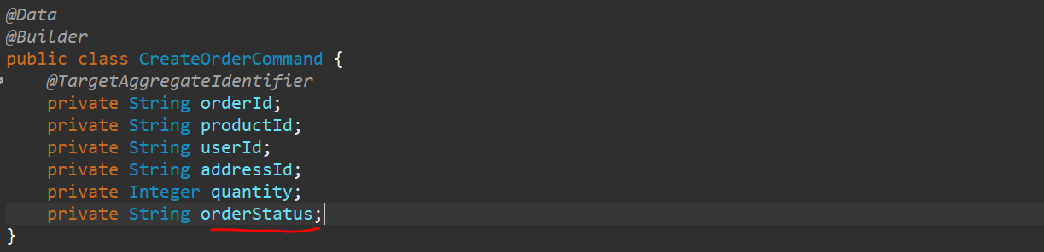

So, to handle this particular command let’s create one **command handler** or we can say an **Aggregate**. Let’s create a package called **aggregate** under **command.api** and create a class called **OrderAggregate**. All the aggregate has been created has to be annotated with **@Aggregate** and aggregate also containing the same fields what we have in **CreateOrderCommand.** In the command we have define @**TargetAggregateIdentifier** so here we will define OrderId as a @**AggregateIdentifier.**

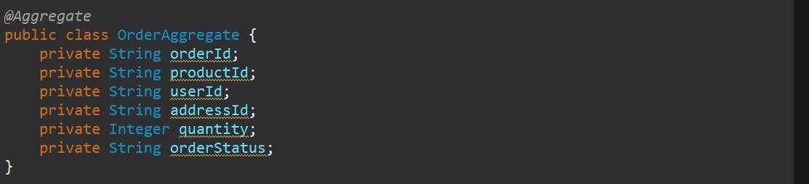

So, your Aggregate is created so now you need to handle this particular command ok the command is **CreateOrderCommand**. So, till now we have not created any **Saga,** so this is not a Saga this is like a simple Event Processing we are doing. We will create a Saga for it. So, let’s first complete this particular parts. So let me create 2 constructors in Aggregate one is default, and another will take command as an input parameter.

Now here we need to handle the particular command now one more thing we need to understand is for all the Aggregates we are handling the Events over here right, so we are storing all the data as event sources like what u saw in Event Sourcing over here at this particular part.



So here selected pizza is there after that u selected cola so at that particular point u can see that pizza is also there. So, the previous event plus the current event all the data has been stored over here. so, for that how the particular Aggregate will come to know is we need to handle the **EventSourcing** as well.

So, we will add the EventSourcingHandler as well that will handle all those particular events what we will do in that particular point is we will update the data. so whatever the fields that we define so for all the different events that we do whatever the fields are getting updated we will update that particular fields to update the status of the event. so first let’s handle the particular command over here. so, this particular command that is **CreateOrderCommand** will create a new event right because command and event will go hand to hand. So, this particular command **CreateOrderCommand** will create an event that is **OrderCreatedEvent.**  So, let’s go and create the event as well.

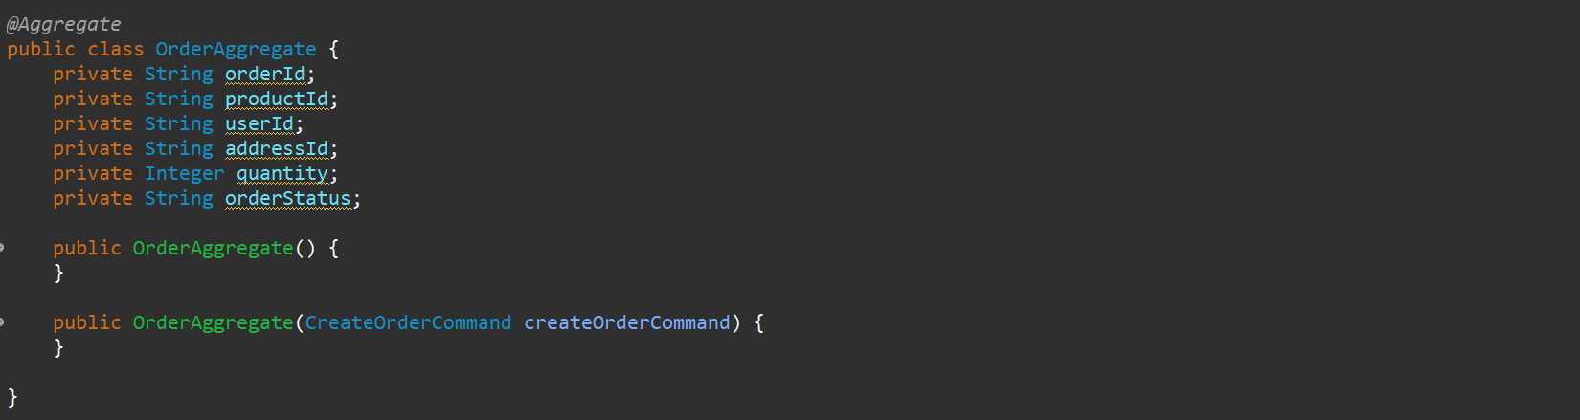

So, in **command.api** package let’s create a new package called **events** and that event called **OrderCreatedEvent**. So, this event should have the payload data. so, I will go to CreateOrderCommand and pick all those fields. So, this is the same payload I want so I will annotate this with @**Data** for our getter setter and default constructor.

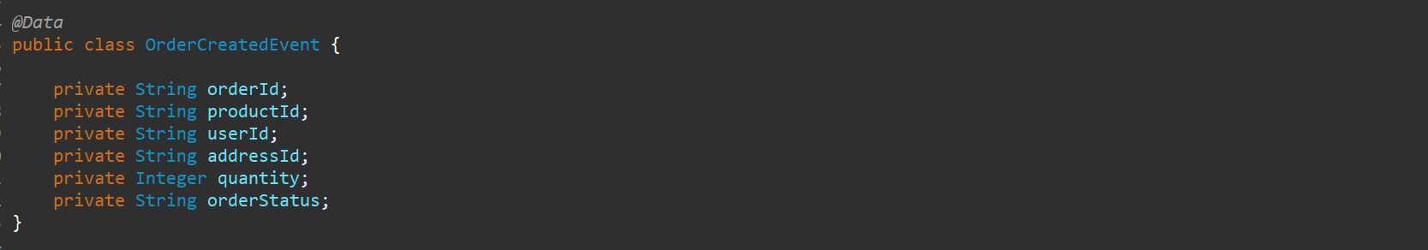

So, for our **command** let’s go back to our **Command Handler** that is our **OrderAggregate.** And we should create an event. So, what I want I want to copy all the status or state from this command to event all the payload data. I will just use the **BeanUtils.copyProperties()** method to copy from source to destination. So, this is just copying the data from here to here and now here I just need to apply the events.

**AggregateLifeCycle.apply() …**what we need to apply we see that was a payload**.** So, my payload would be event that OrderCreatedEvent. So here the event would be handled.

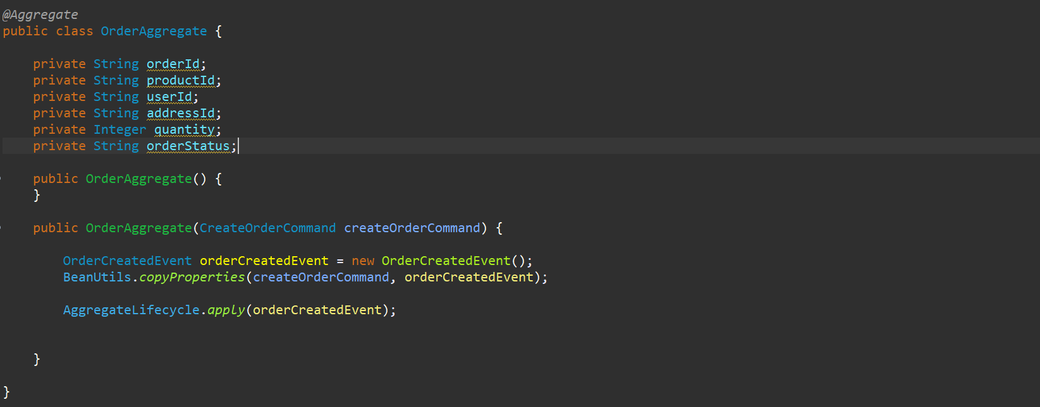

**AggregateLifeCycle.apply() …**what we need to apply we see that was a payload**.** So, my payload would be event that OrderCreatedEvent. So here the event would be handled.

Now, but if u go to the **Controller** over here…so from here we need to publish this particular **command** to the **CommandGateway** then only our Aggregate would be able to handle that. So here we will be needing the **CommandGateway** over here. so, let’s create the object for it. Let me use the constructor so that will initialize the **CommandGateway**. **CommandGateway** is the part of axon framework and I need to get the data from the **OrderRestModel,** and I need to populate the **command**.

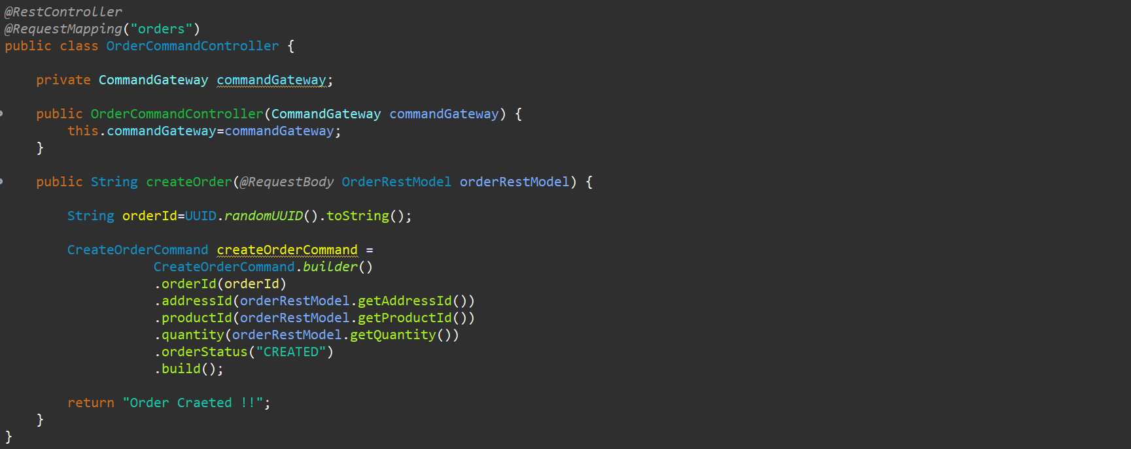

So, our command object is created so now I need to send this command. so, I need to use

**commandGateWay.sendAndWait(CreateOrderCommand)**

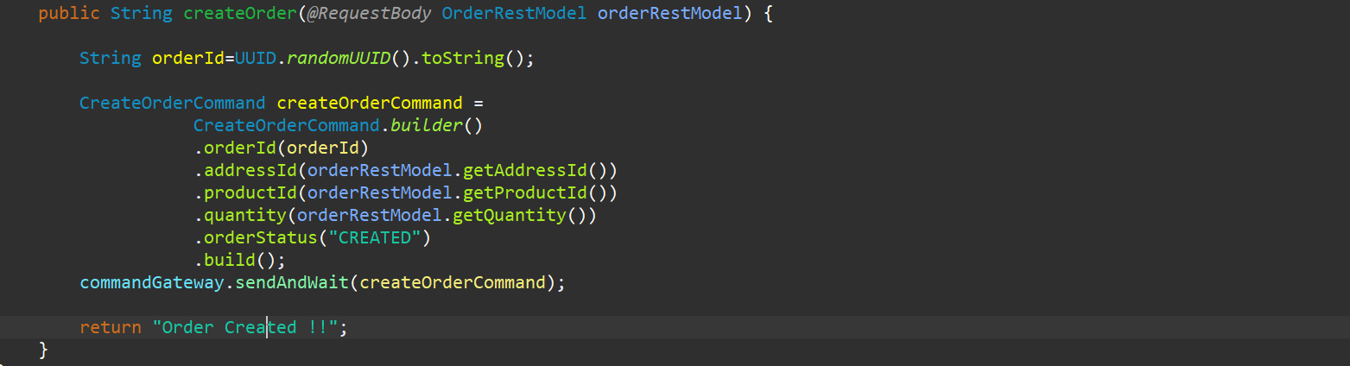

Its very simple thing whatever the data we are getting over here we are we populated all these details in command and that particular command we send via **CommandGateway**. So, this particular command will be handled by the **OrderAggregate** over here. you can see we have injected this particular command in **OrderAggregate** so here what we need to do is we need to validate this particular command.

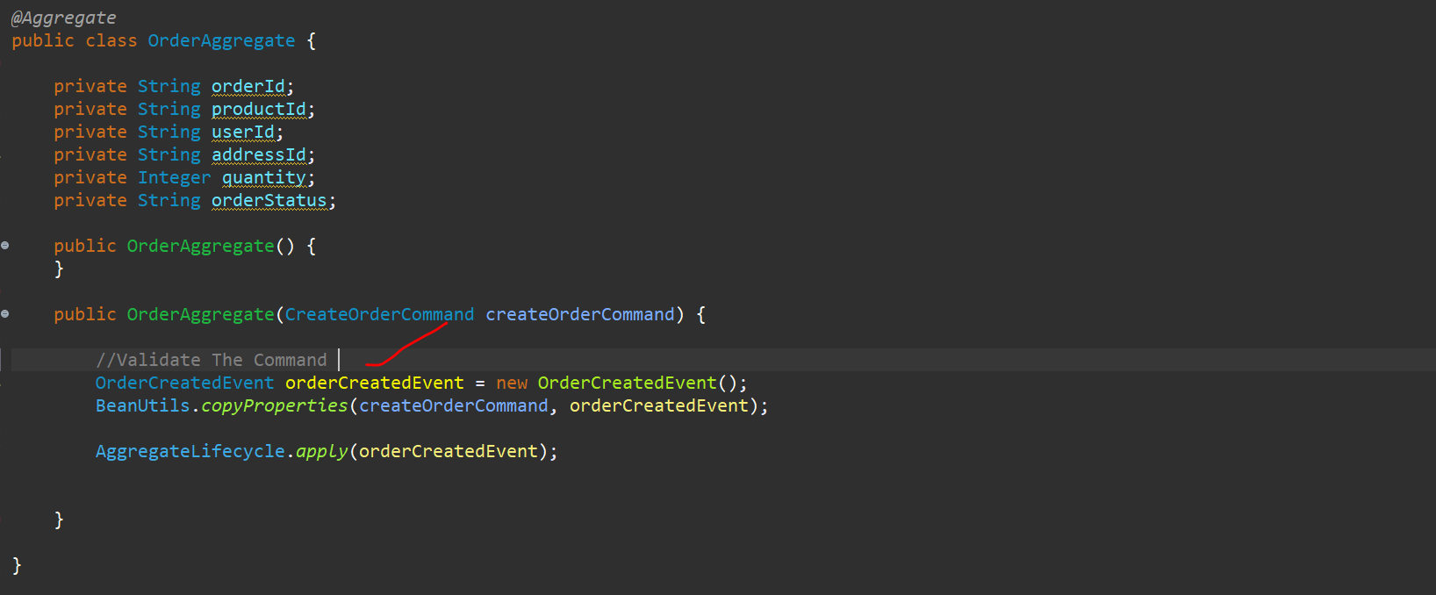

so here what we need to do is we need to validate this particular command. what type of validation like what all details we have got are correct or not all that type of validations and the business logic everything u can validate over here once the validation is successful u can create this particular event like we have created the event **OrderCreatedEvent**. We created the class for it and we populated all the values over here populated the payload and we apply the event in the **Aggregate Lifecycle** that means we sent the data to the **axon server**. Now we need to annotate this particular with the Command Handler bcz we are handling the command over here.

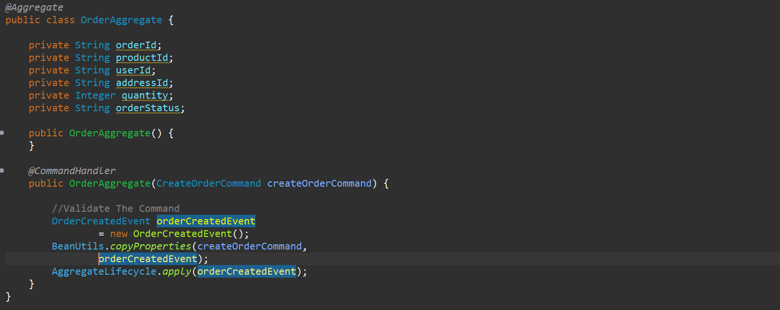

Let’s go to the controller and this is our POST Mapping.

Now go back to **Aggregate**, as we told we need to handle EventSourcing as well. So, whenever the event you creating you need to handle as well. So, let’s handle that as well over here. so, whatever the data you are adding in the event that has to be updated in my aggregate as well.

So, we are handling this event over here and we are injecting it over here and annotating the method with @**EventSourcingHandler** and whatever the values are there in this particular event we need to update to our **Aggregate**.

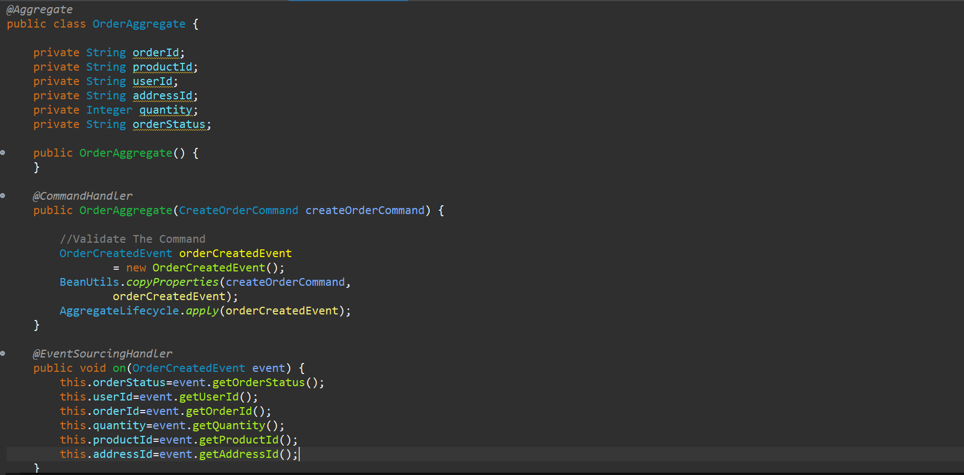

So, I have handled the Event Sourcing as well. So, whatever the event is created that particular data I am updating in my **Aggregate** as well.

So, this is my first event that I have created. Now based on this particular event I need to handle a series of **commands** and **events** over here. so, this is a perfect place to start our **Saga** and we will be creating the **Saga** in Service which will be starting the starting **event** over here or starting the **command** over here. so, in this particular case that’s the **CreateOrder** one so, we will be creating the **Saga** in this particular service. so, to create the Saga let me create the package over here **saga** over here in **command.api** withclassname **OrderProcessingSaga**.

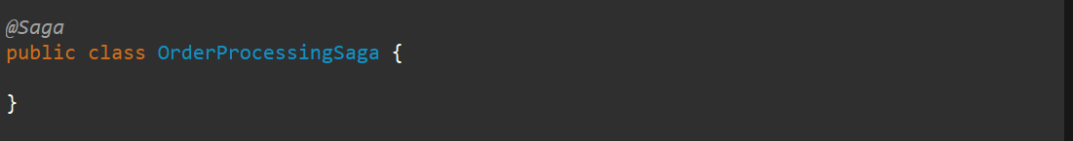

Now in this particular **Saga** different things u need to take care. So just annotate this class as a @**Saga** so, this will behave as a **Saga** and after this every event will be either starting the **saga** or ending the **saga**. So, u should be having the start saga annotation and the end saga annotation in either of the events bcz there has to be the start saga and there has to be the end saga u can do by the annotation as well or by the programmatically as well, but u need to make sure that u start the saga and u end the saga. All the event that u handled has to annotated with @**SagaEventHandler** bcz this particular events are the saga events. @Saga presents in **axon framework**.

If u see **OrderCreatedEvent** so, to handle this particular event you will be using the @**EventHandler** annotation and to store the data ….but when u are handling the same event in ur Saga u need to annotate with @**SagaEventHandler**. This is just a basic thing over here so, before we do anything in the saga let’s just go and complete one single event that is **OrderCreatedEvent** and let’s store the data. So, we will create one Event Handler that will complete the particular event and Saga will handle that as a Saga event. So, in event package let’s create a class called **OrderEventsHandler**. Now this particular Event Handler should handle the event that was created from this particular aggregate that was **OrderCreatedEvent** and whatever the data it has it has to store in the database.

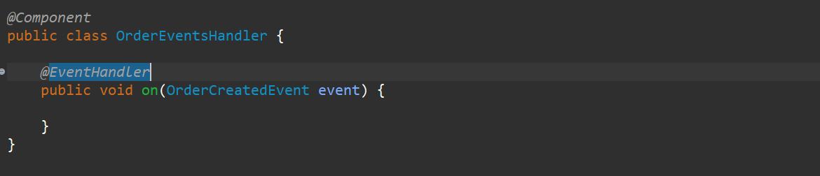

Now here what we need to do is I need to handle the event that mean I need to store the data. so, for that we need Entity and Repository as well. So, let’s create a package called data in command.api and create an **Entity** and **Repository**.

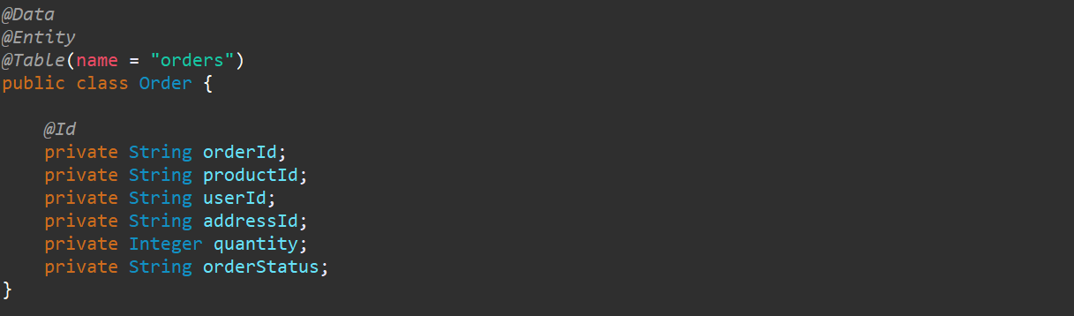

To handle this entity now we should have a **Repository**.

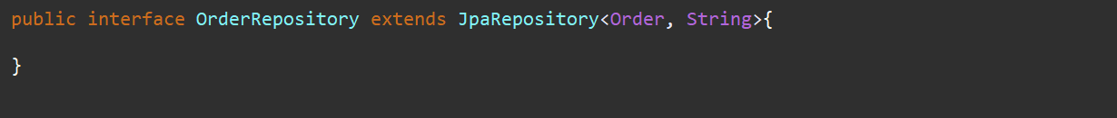

Now I need to create the object of an Order as well to save the data.

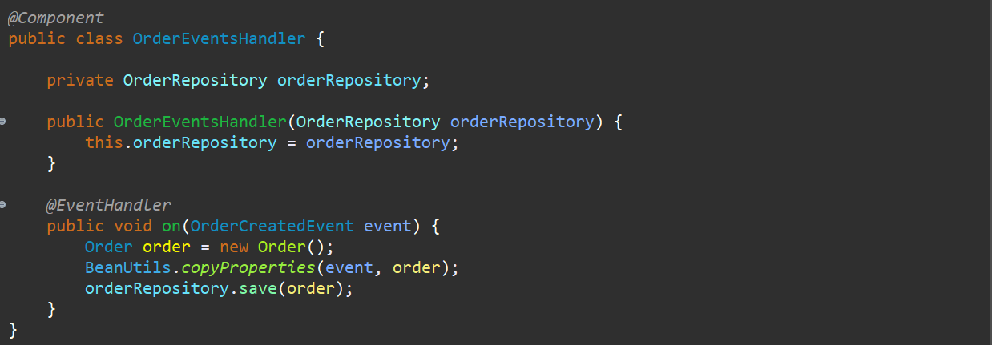

So, we have handled the event **OrderCreatedEvent** using the @**EventHandler** to save the data now I need to handle the save event from the Saga as well because this particular same event will create the series of other commands and event as well so let’s go and do that, we will go **OrderProcessingSaga** and here we need to handle the same event.

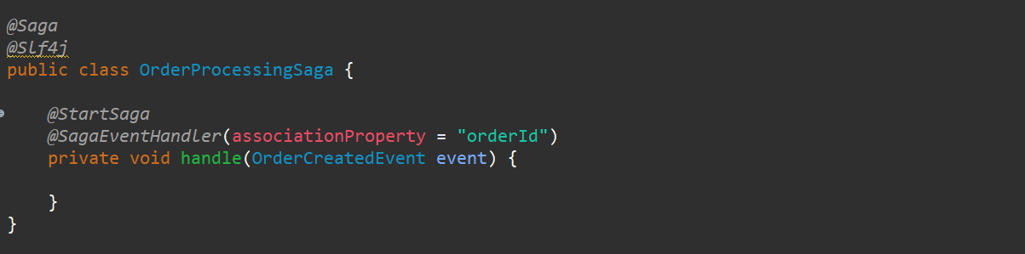

And this should be @**SagaEventHandler** and all this particular **SagaEventHandler** should have the association property to associate with ideally u should give the whatever is there your **primary** key it should bethe unique value. for us it is **orderId** so, I am giving the orderId here. now this particular event the first event that is **OrderCreatedEvent** is the starting point to start our **Saga**. So, I ll annotate with @**StartSaga**. So, this particular will start the Saga. So whenever u are working with Saga all this particular data will be store to ur database as well so what is the saga id and all details u can see in db. I will show u what are the fields as well how it is storing the data as well. From that only it will be able to understand how to handle these particular events that we are creating.

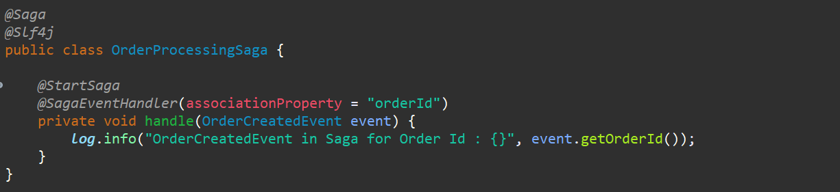

Let me just log it for now. So, we will get to know like **OrderCreatedEvent** was executed in the Saga for a particular order Id. Now this particular event should trigger some of the other’s command right …



So, u can see **OrderCreatedEvent** from Saga should trigger **ValidatePaymentCommand.** So, we need to have this particular **ValidatePaymentCommand** created, update all the value that we have. We have to update the **payload** so we will update the payload and we will send this particular command via **CommandGateway** so any of the other CommandHandler can handle this particular command and create a new event. It’s just a series of **commands** and **events** that has been tight together to handle the entire operation. So, nothing fancies it’s very easy. once we see the entire process, we will have the complete idea about the saga design pattern.

This first Saga Event Handler should be creating the command that is **ValidatePaymentCommand**. Now this particular **ValidatePaymentCommand** has to be use in this particular **Order Service** as well bcz we are having this particular **OrderProcessingSaga** over here and that particular payment need to be handled in **Payment Service** as well as it is in multiple places, we will keep that particular command in our **Common service** so let’s go to a **Common Service** and let’s create the package.

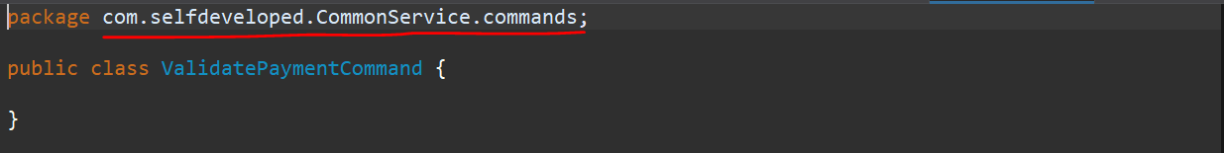

Now for this particular command what is the payload that we require that you need to identify that, and we need to add those particular fields and we need to update it accordingly from the Event Handler.

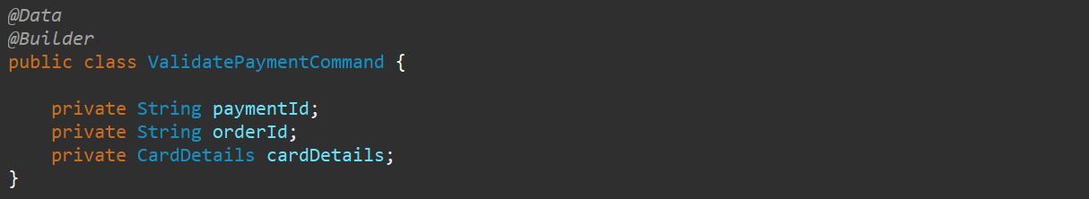

paymentId is unique identifier for it. orderId for which particular order the payment is. card Detail is how the payment is made either using debit card or credit card…for that we created a model for it.

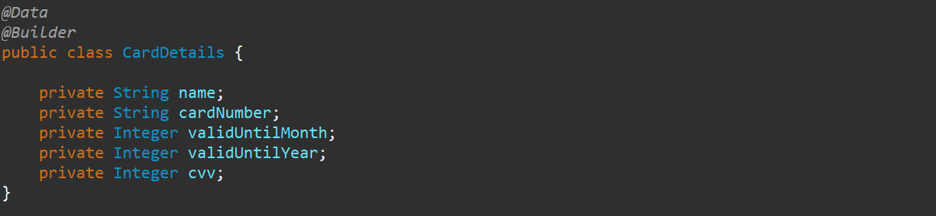

So, I am having my paymentId, orderId and cardDetails from which that particular payment should happen.

Now, I need to create this particular command from the **OrderSaga.** So, let’s go back to the **OrderProcessingSaga** and here we need to create the command that is **ValidatePaymentCommand** this command we need to send. Now this particular command needs few details bcz this is the payload right. This payload required the paymentId, orderId and the cardDetails. So, these all details should be already saved in your user profile. So, we need to get all these details from the **User Service.** so, we need to have the query created for it and to fetch the details for it. Then only we will be able to store all the details. So before we set anything in **ValidatePaymentCommand** before we send this particular command we need to create a query, get the details from the query and update over here. so for that in OrderSaga itself we will do that. Its not advisable its always should be a different one but for the shake of understanding and simplicity so, to set all the details over here we need to get all the details based on the **userId** that we provide. Based on the particular userId what are the particular card details and the paymentId for it. So, we need to create a query and that query should be handled by the User Service that we have.

As this is also the common query so, let’s go and create in the common service over here. so, in common service as we created the **commands** package so let’s create the new package called **queries.** We have created a class called **GetUserPaymentDetailsQuery**. Now for this query and command you will get to know more about in the **CQRS** tutorials. command is to do some operation to tell to do some operation and query is to fetch the data that is already been saved in your database. query will also have the payload details. So, what payload I need to send is **userId**.

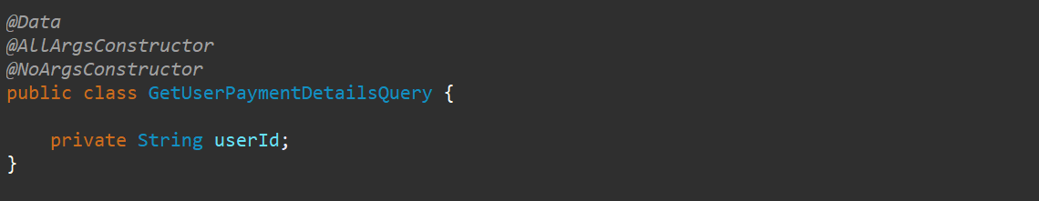

So, I just created one query with one field userId once I pass userId and to get and pack the details of the user payment and the entire object.

Now let’s do the handling of this particular query. Now this particular query needs to be handled by the **User Service**. so, in user service as this is query so we need the Query Handler. **Query Handler** can also be known as the **Projections**. So, let’s create the **projections** for it in **User Service**.

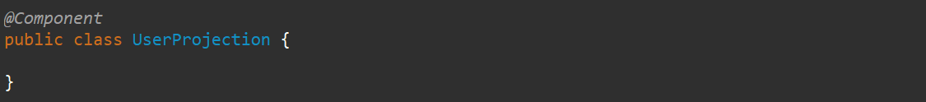

Let me annotate with @**Component** so that it would be there in Spring Radar. Now from this particular point we need to send the entire object back a **user** right. So, we need to create the model. So that particular User should have the details like the userId which we are passing so for that particular userId I need to pass all the details like firstName, lastName and the cardDetails that we want and for that we need to create a model and as that particular model is being used by this particular **User Service** and **Order Service** so, we will create in the **Common Service**.

In **User Service** in model package let’s create a class called **User.**

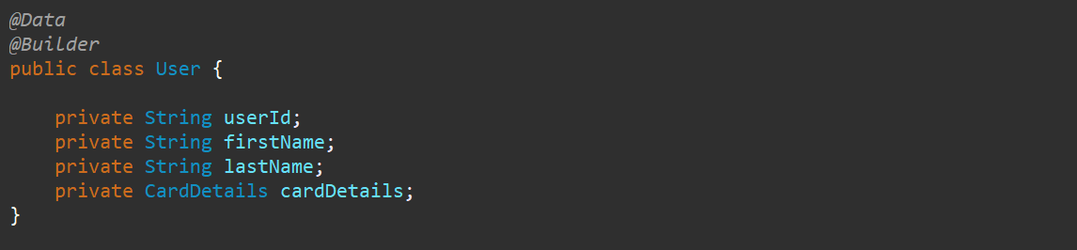

So, this is my model created now I can return this model from my **User Service**. so, let’s go back to the **UserProjection** here and let me handle that particular **query**. And let me annotate that method as a @**QueryHandler**.

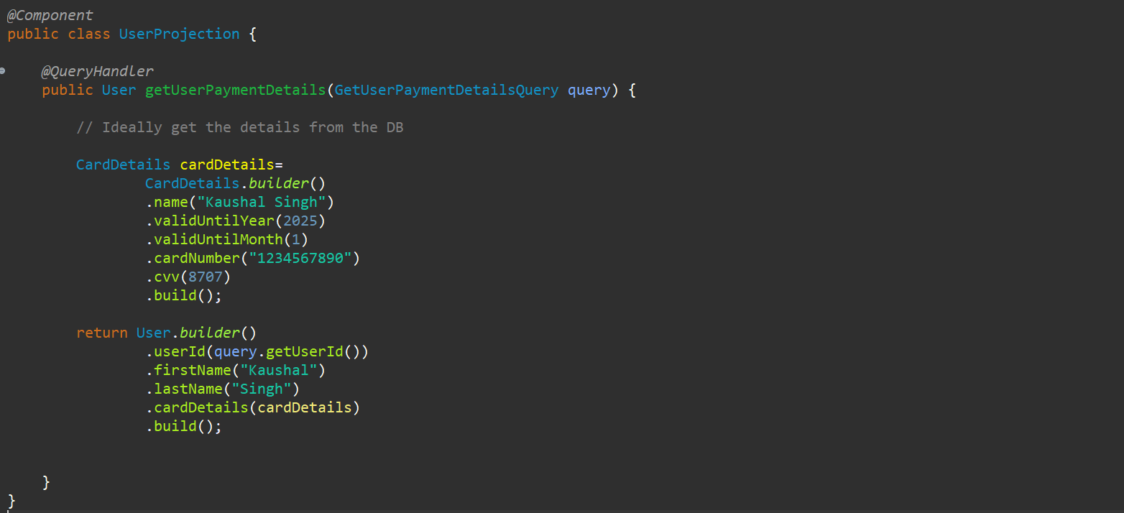

So, I am just returning the User details over here. this is the static details I am passing from here to save the time but ideally based on this particular userId that we get over here from this particular query we need to get the data from the database, and we can send the data.

So, this particular User details we will get from the **Order saga**. So, go to the Order saga and we need to get the details over here and set the values.

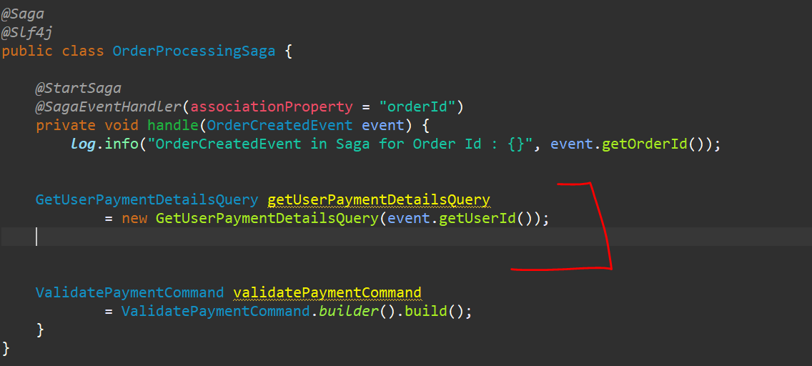

Now I need to send this query and get the data back. Now here I need to have the **QueryGateway** to send this particular query and let me create the object of a **CommandGateway** as well. So, wherever it’s needed we can use.

We are using **QueryGateway.query(**Query query, ResponseType.class**)** method…

As this is the Completable feature object so, I need to wait until I get the data. so, I will use join over here.

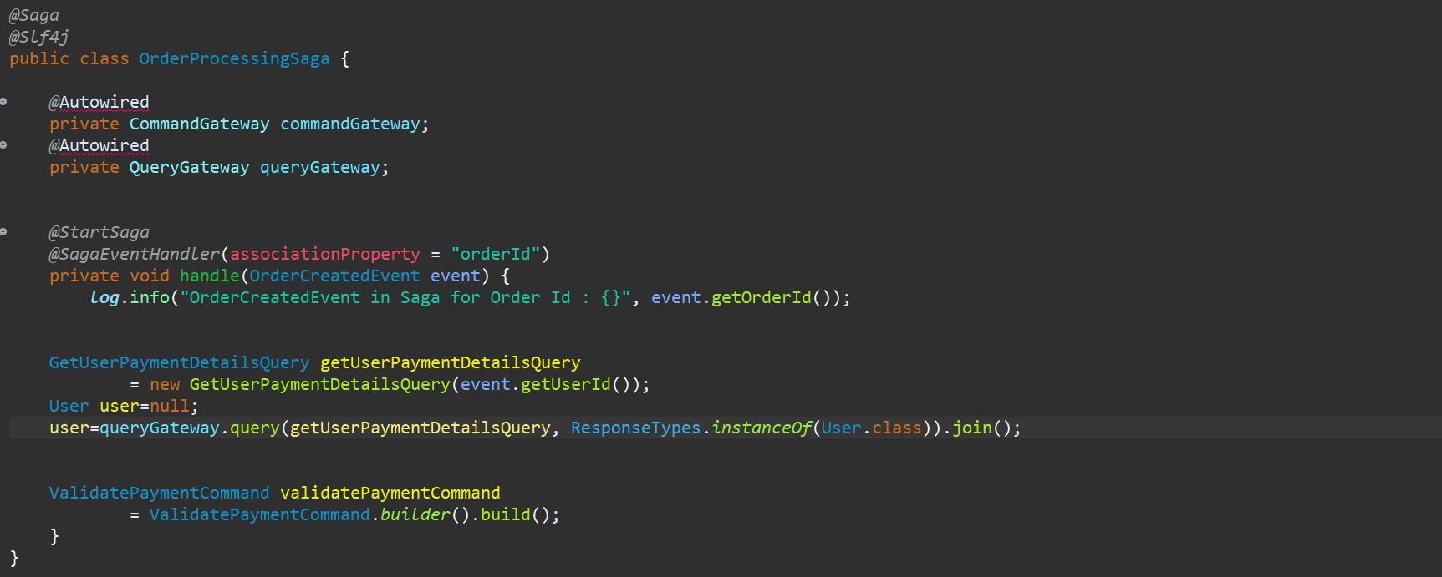

I have just created the query over here and I was just passing the query using **QueryGateway** and we are just waiting to get the details back over because these details are very necessary for our next command.

So, we are waiting. There might be 2 chances we are getting the details from User Service, or we are not getting the details from the User Service. so, at this particular point we need to handle that particular exception as well. If we are getting the details, then only we will be able to pass the details in this particular **ValidatePaymentCommand** and we can proceed a head otherwise we need to cancel the order as well so, let me just add try catch over here.so, whatever this particular thing is there let me add inside try block.

If is there any error let me start the **Compensating Transaction**.

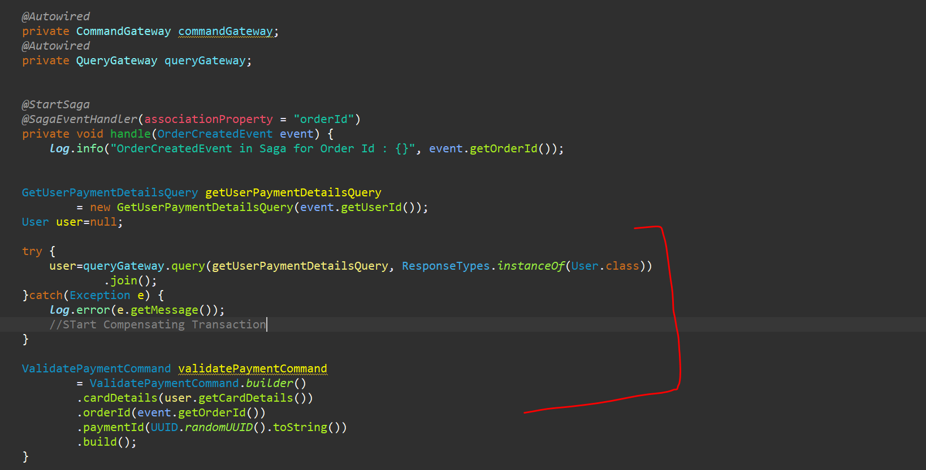

Now assuming User is not null, and we got the detail over here. we need to set the values in the **ValidatePaymentCommand** because you are still stuck at this particular command, we have not done anything, yet we are just doing to get the values so now let’s **set** this particular values.



cardDetails, we got from the user object, orderId we will get from this particular event and the paymentId will be a new unique payment id- i.e nothing but a UUID.

Now ValidatePaymentCommand we have Created. Now what I need to do is I need to send this particular command, so I will use

**commandGateway.sendAndWait(ValidatePaymentCommand).**

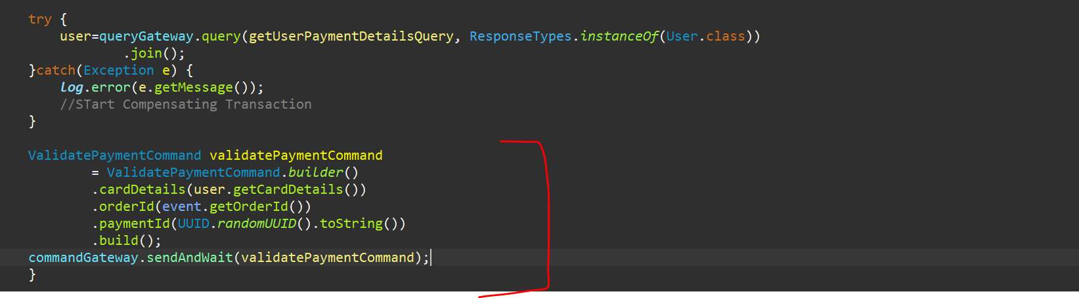

Now we have sent this particular command to the CommandGateway. Now we need to handle this particular command from the **CommandHandler**, and we need to create the Event or either we need to create the compensating event as well. So, let’s think first positive scenario if **ValidatePaymentCommand** is successful we are handling everything is valid and we can create the **PaymentProcessedEvent** and all this particular things we need to handle in **Payment Service**. so let’s go back to the payment service over here.



So, In Payment Service let’s create the packages **command.api**. within this command.api package let’s create the package **aggregate** and **events** as well and we will create the package for handling the data i.e **entity** and **repository**. bcz, we need to save this payment details as well. Now to handle this **ValidatePaymentCommand** in Payment Service let’s create the **PaymentAggregate**. So, Aggregate is your CommandHandler. Create a class PaymentAggregate and annotate with @**Aggregate**.

If you go back to **ValidatePaymentCommand** ur paymentId should ur **TargetAggregateIdentifier**. Because that be your unique thing.

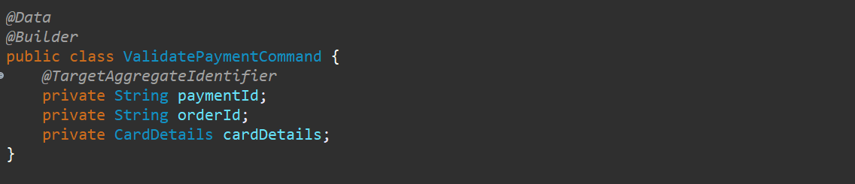

Now let’s go to the Aggregate and I need to have this all-particular fields. So, fields would be paymentId, orderId and PaymentStatus. And your paymentId would be your @**AggregateIdentifier**. So, the same way what we have in **OrderAggregate** we need to do here. we need to have a constructor and a constructor with injecting a command and this particular will be your **CommandHandler**.

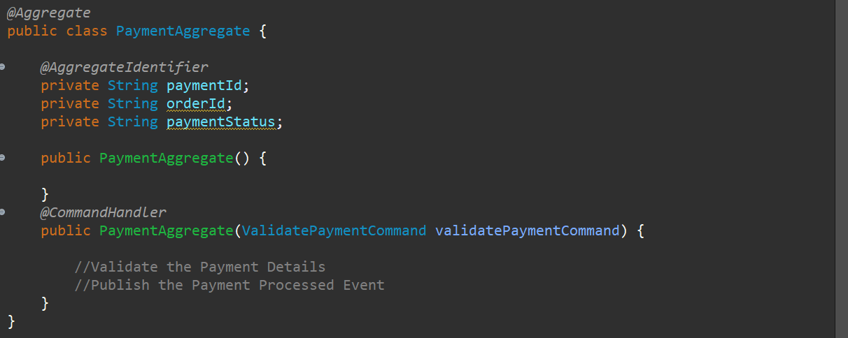

Inside the Command Handler we Validate the Payment Details and Publish the **PaymentProcessedEvent**.

So, whatever the validations we want to do in this particular command **ValidatePaymentCommand** so, we have the payload like values are there or not values are matching or not and once everything is successful, we publish the event.

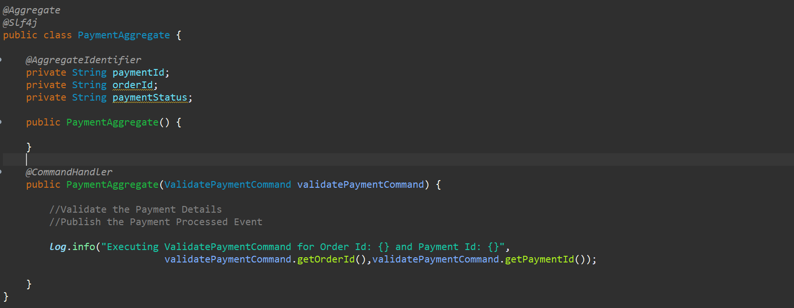

Now as this part is done, we need to publish the event so, first we need to create the event. As that has been used in 2 places so let’s go and create in **CommonService**. So first let’s create a package called **events.**

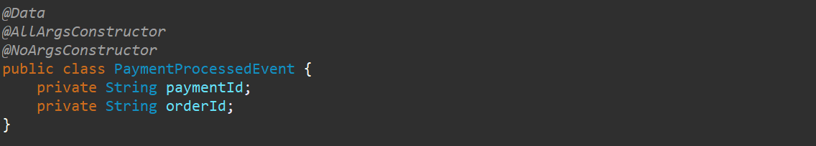

Simple event that we have created. Now this particular event has to be handled at 2 places. We need to handle the event and store the data in database in **PaymentService** itself and this particular event will be the trigger point for the next event that we need to handle in our **OrderProcessingSaga.**



So, you can see **PaymentProcessedEvent** will again trigger the **ShipOrderCommand**. So, this has to be handled by this particular Saga as well as a Saga EventHandler and in the same particular service service as well to handle the event and store the data in the database. so, let’s go back to **PaymentAggregate** and here I need to get all the particular values from the command and populate all the things in your event and publish the event. I have just passed the 2 values in the constructor and object of **PaymentProcessedEvent** has been created. Now we need to apply this event into AggregateLifeCycle.

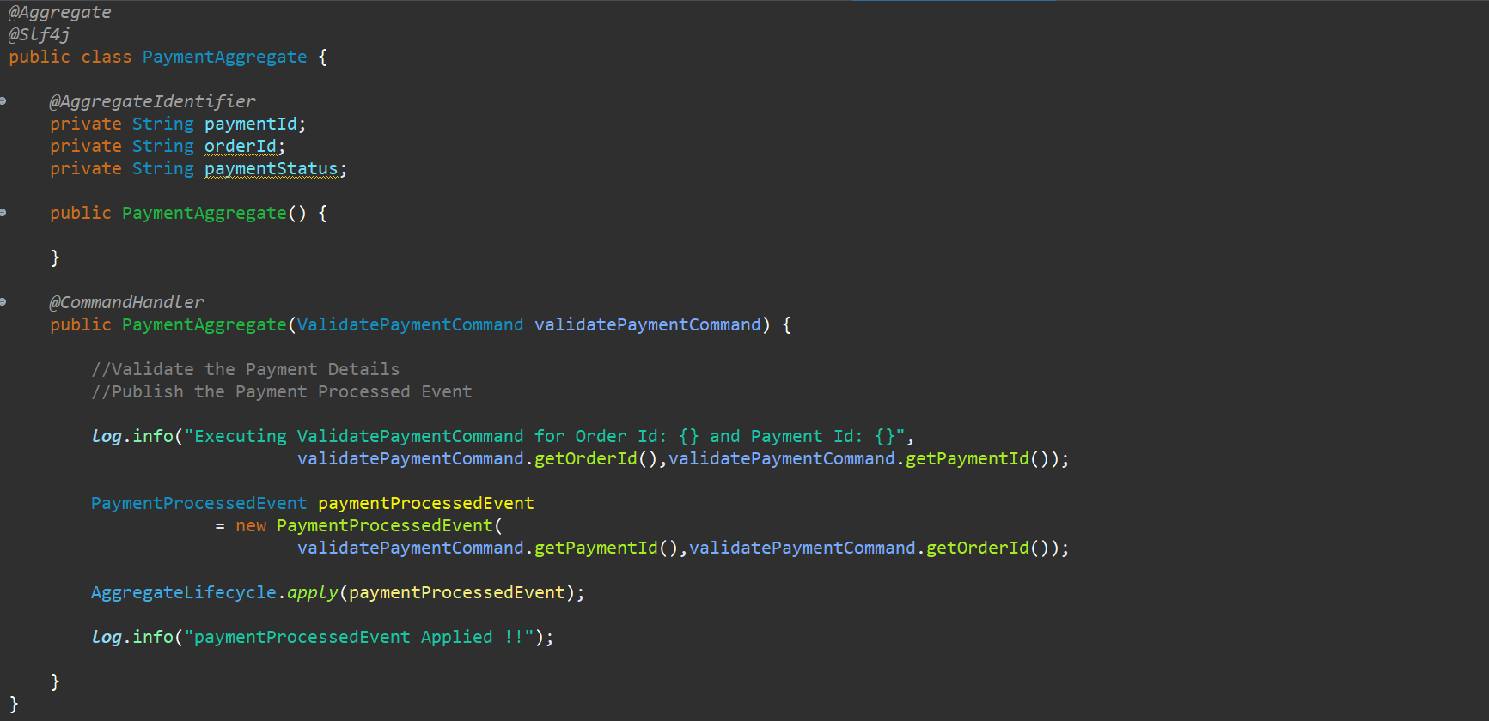

Now we need to handle the EventSourcing as well to populate the fields that we have added in the aggregate. So, let’s do that. And we need to update the fields.

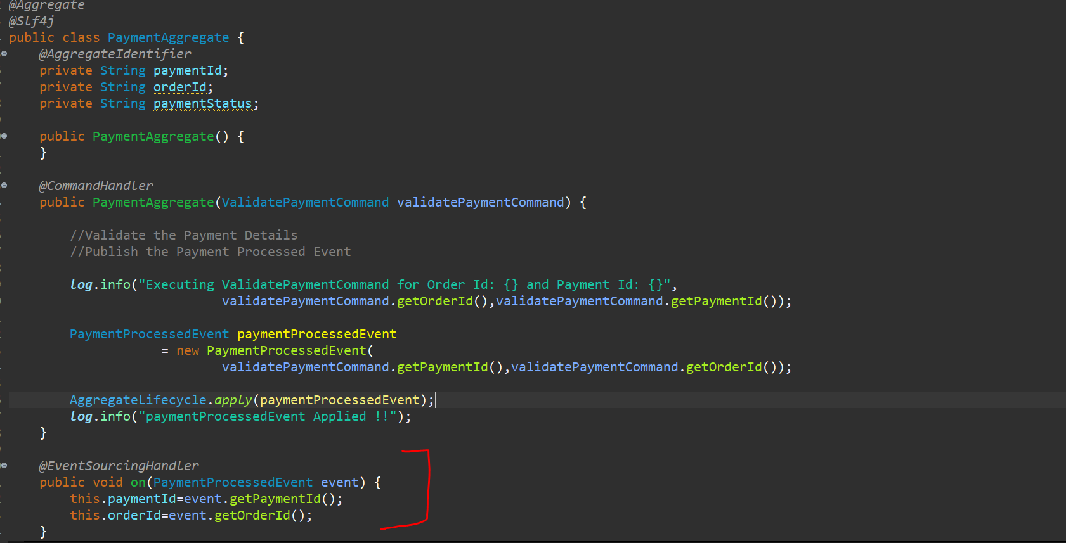

So, we just handle the command and publish the event. Now handle the same event in the same service and also handle the same event in the **OrderSaga**. In Payment Service let’s create a class called **PaymentsEventHandler** and create a method and annotate with @EventHandler of axon framework. Now at this particular point I need to save the data so let’s create a Repository and Entity.

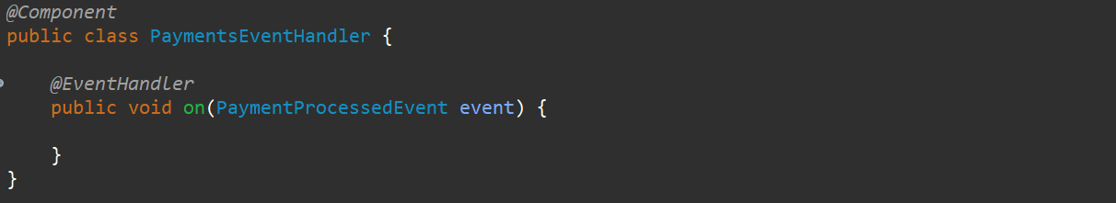

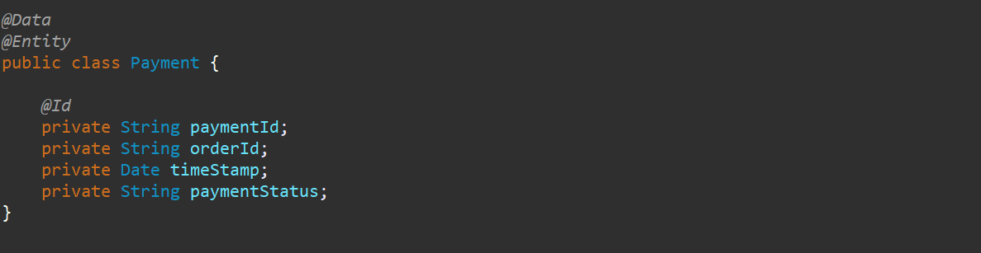

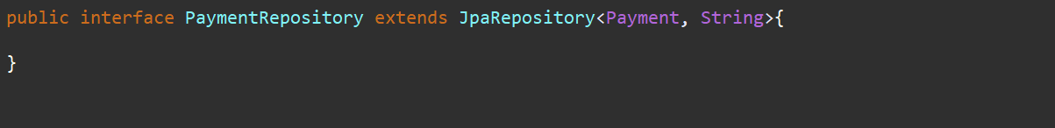

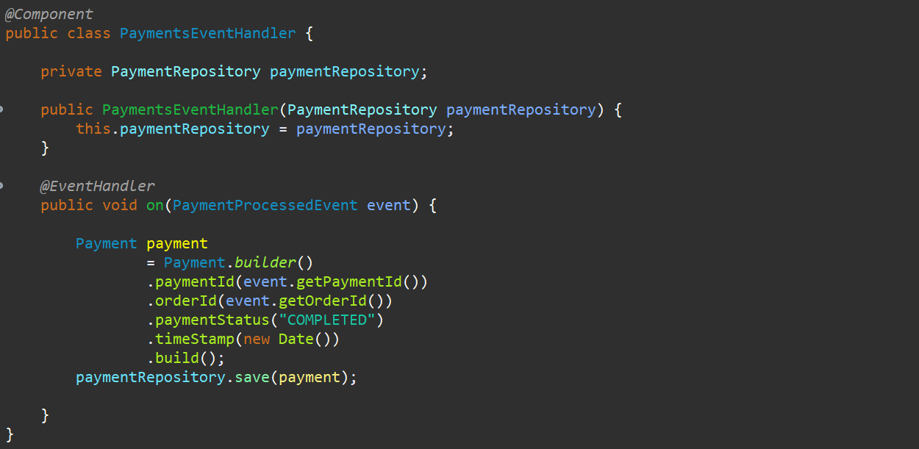

This particular event has been handled and we store the data now we need to handle the same event as a **Saga Event Handler** as well. So, let’s go to the OrderSaga again and now we have this one particular event Handler (below we marked as a crossed signed but its valid for reference) already right now let’s go and create the different one.

***~~@StartSaga~~***

***~~@SagaEventHandler~~*~~(associationProperty = "orderId")~~**

**~~private void handle(OrderCreatedEvent event) {~~**

***~~log~~*~~.info("OrderCreatedEvent in Saga for Order Id : {}", event.getOrderId());~~**

**~~GetUserPaymentDetailsQuery getUserPaymentDetailsQuery~~**

**~~= new GetUserPaymentDetailsQuery(event.getUserId());~~**

**~~User user=null;~~**

**~~try {~~**

**~~user=queryGateway.query(getUserPaymentDetailsQuery, ResponseTypes.~~*~~instanceOf~~*~~(User.class))~~**

**~~. join();~~**

**~~}catch(Exception e) {~~**

***~~log~~*~~.error(e.getMessage());~~**

**~~//STart Compensating Transaction~~**

**~~}~~**

**~~ValidatePaymentCommand validatePaymentCommand~~**

**~~= ValidatePaymentCommand.~~*~~builder~~*~~()~~**

**~~.cardDetails(user.getCardDetails())~~**

**~~.orderId(event.getOrderId())~~**

**~~.paymentId(UUID.~~*~~randomUUID~~*~~().toString())~~**

**~~.build();~~**

**~~commandGateway.sendAndWait(validatePaymentCommand);~~**

**~~}~~**

For SagaEventHandler let me use the same association property **orderId**

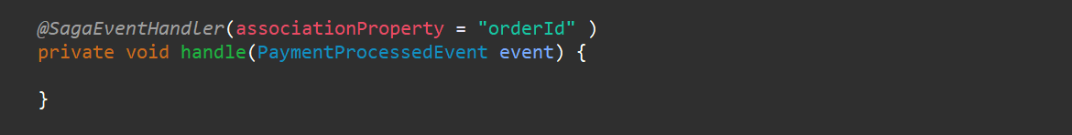

Once the PaymentProcessedEvent has been handled we need to send it to the **ShipOrderCommand** so from the diagram you can see we have a ShipOrderCommand.



So, let’s create the **ShipOrderCommand** and this command also has to be handled by the **ShippingService** and **OrderProcessingSaga** as well, so we need to have in the Common Service. for every command we do TargetIdentifier so **shipmentId** will be the TargetIdentifier.

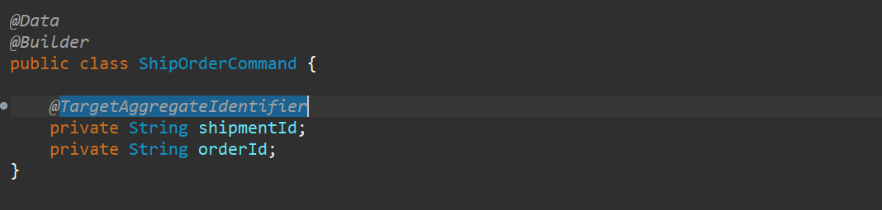

Let’s go back to the **OrderProcessingSaga** and let’s create the object of it and let’s set the value as well. shipmentId would be the random id, orderId we ll get from the event now the payload of the command is created now let’s send this command using the CommandGateway.

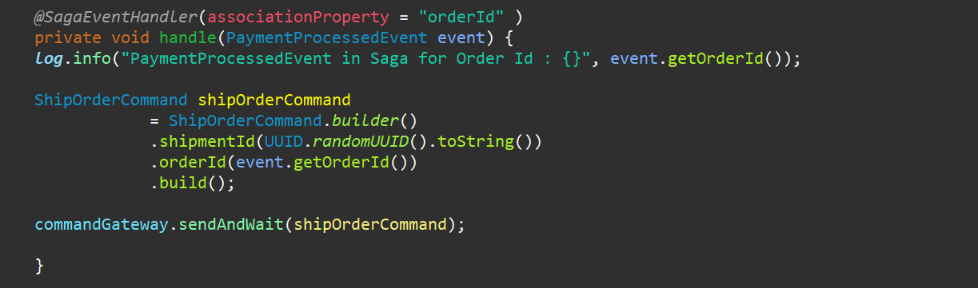

And this also may contain the error so, let’s surround with the try and catch block. If is there any error just log the error and start the Compensating transaction for it.

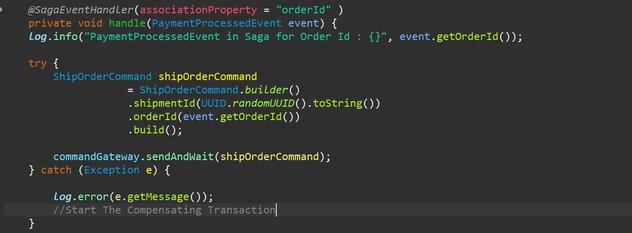

This particular command ShipOrderCommand is handled in the **ShipmentService** as well. So, let’s create the packages and handle this. we have created the packages command.api and under this **aggregate**, **events** and **data**.

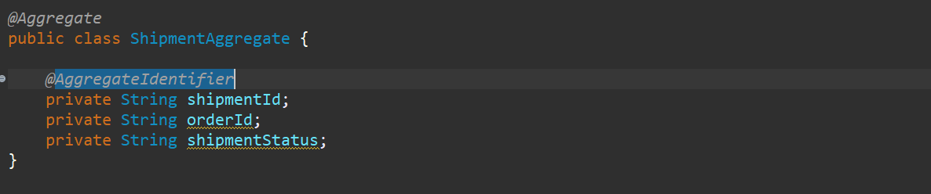

shipmentId to be annotated with @**AggregateIdentifier** to match with the **TargetAggregateIdentifier** in the **ShipmentCommand**. Now this aggregate should have the one default constructor and another constructor with **ShipmentCommand** parameter. Validate the command and publish the **OrderShippedEvent**.

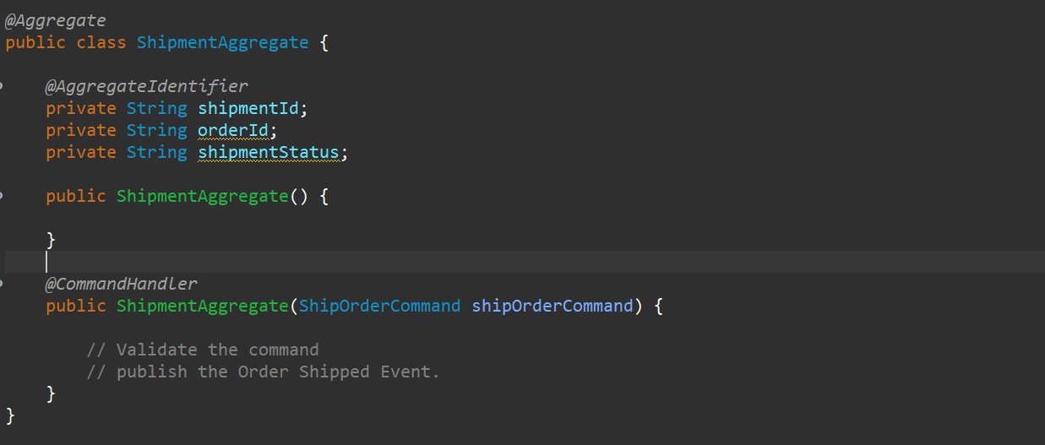

Now this has to be have the Order Shipped Event. So, we need to create the event so just go back to the Common Service.



So, if u see the diagram ShipOrderCommand again create the OrderShippedEvent. So, whatever the properties are there in aggregate let’s add in event as well. Just added the payload detail.

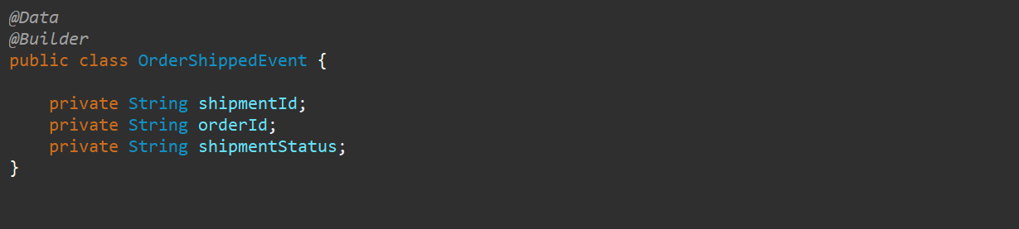

Now we need to publish this particular event. So, we need to go to the **ShipmentAggregate**. Now we need to create the event using the command and need to publish the event.

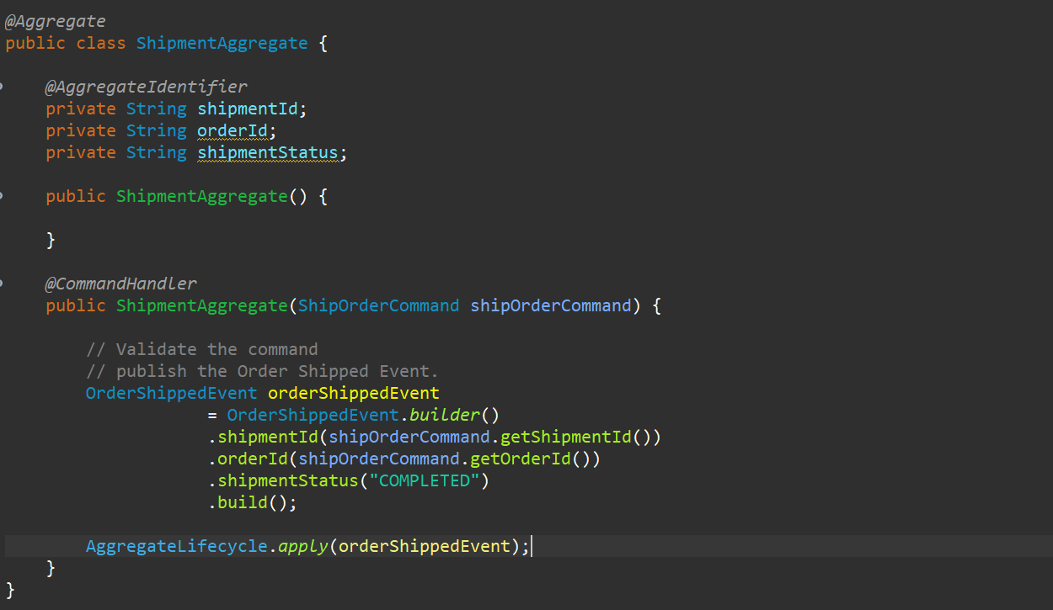

Now every **Aggregate** whenever you are publishing the event you need handle the **Event Sourcing** for it. So, let’s handle that. What we will do we will just update the particular aggregate fields over here.

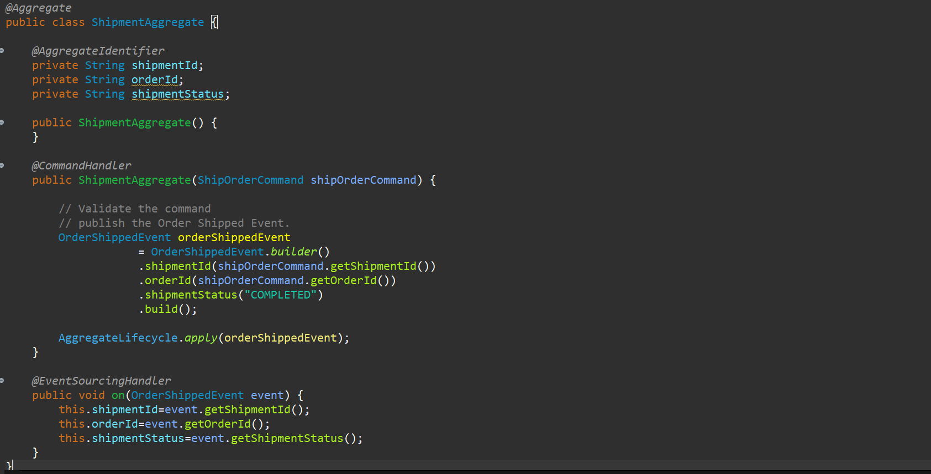

So, the event sourcing has been handled now this particular event **OrderShippedEvent** has been published has to be handled at 2 places within the same service to store in the database and to handle in the Saga to handle as a Saga Event Handler to publish the new command. so first let’s handle it into the same service to store the data. so, in package of events in ShipmentService let’s create the **ShipmentEventHandler**. This particular EventHandler will save the data in database so let’s create entity and repository. it’s just the repetition of what we did in payment service and order service.

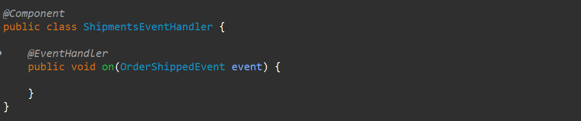

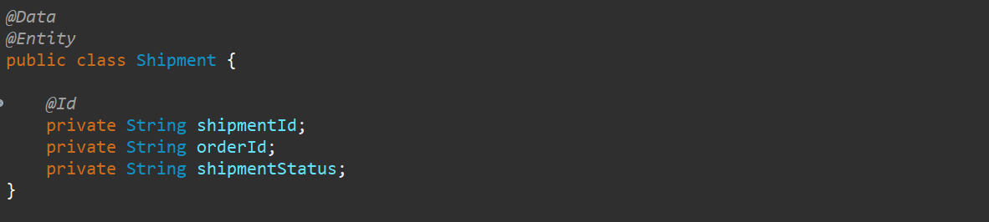



Let’s get back to ShipmentEventHandler and handle it. So, using this event handler we are just saving the shipment detail in our database.

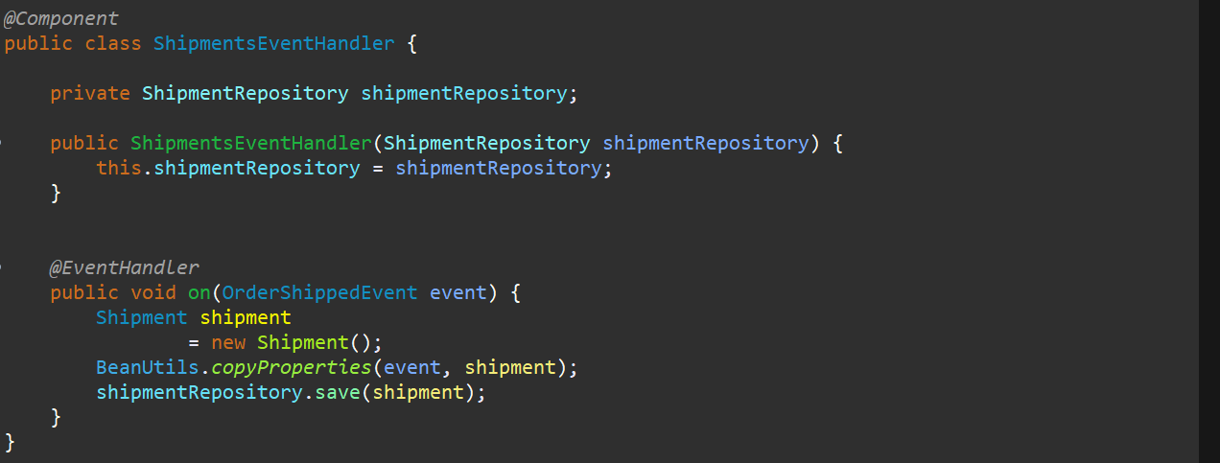

Now this particular event should also be handled by the Saga Event Handler because this event will again result in the another command or it will be the end of the saga as well. Whatever is feasible but u need to handle that event. So, let’s go to the Order Saga. We have 2 events already **OrderCreatedEvent** and **PaymentProcessedEvent**. Let’s create the 3rd one **OrderShippedEvent** and this should be **@SagaEventHandler** with association property **orderId**.



Now what will be the result in the **OrderShippedEvent. OrderShippedEvent** will create the **CompleteOrderCommand** that is result in the completion of our order. So, let’s go and do that. **OrderShippedEvent** will result in the **CompleteOrderCommand**. So go to the common service and add that command.

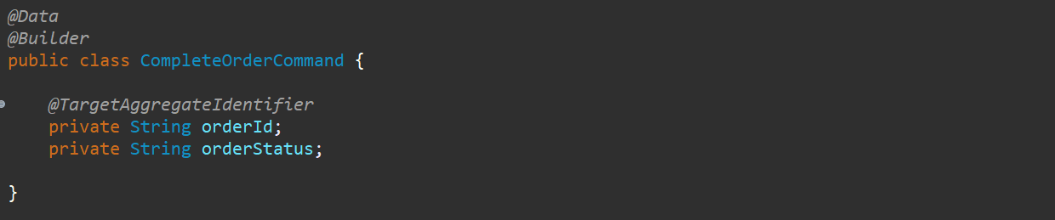

Now my command is ready I need to send this particular command. so, let’s go to the **OrderSaga**.

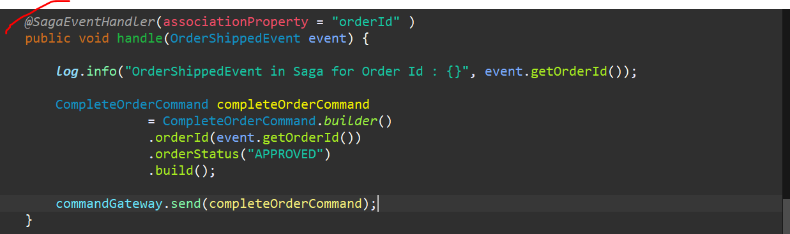

Now this particular command is being send using CommandGateway. Now Aggregate will be handling this particular command and created the new event that is **OrderCompletedEvent** over here. so, we are just going through the +ve scenario over here we are not going -ve scenario as of now. Let’s first complete this one …

So OrderCompletedEvent will be doing so let’s do that. So, Order completed event has to be handled by the Order Service. so, let’s go to the OrderAggregate in the Order Service. there are already one **CommandHandler** and one **EventSourcingHandler**. So, let’s create the new **CommandHandler** and new **EventSourcingHandler**.

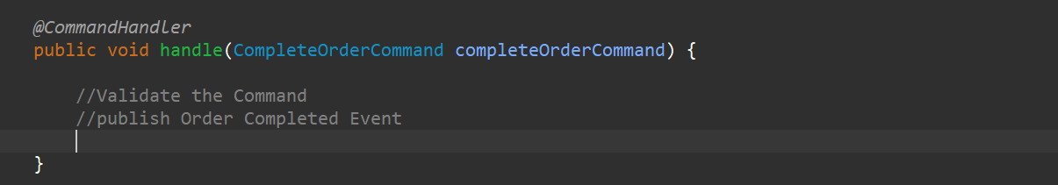

So, here we are doing 2 things Validate the **CompleteOrderCommand** and if everything is validated successfully, we need to publish the event **OrderCompletedEvent**. So, go to the **common service** and create the event.

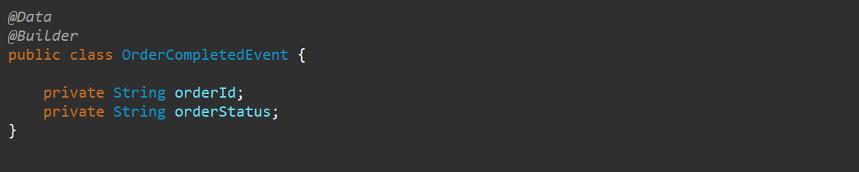

Let’s get back to the **OrderAggregate** and from here we need to publish that particular event.

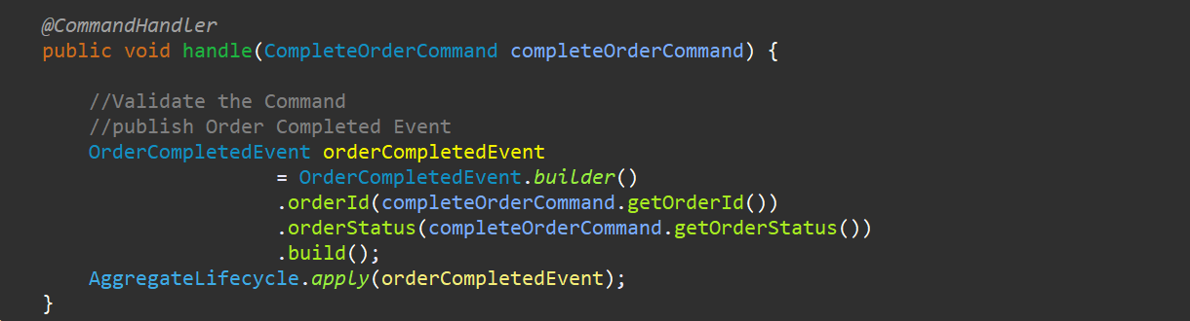

We have created the event and we are publishing the event. Now this particular event has to be handled at 2 places the same like Order Service as well plus Order Processing Saga as well. So, first let’s handle this particular event from the EventHandler from the Order Service and update the order details and then we will handle using Order Processing Saga as well. Before that I forget we need to do the EventSourcingHandler as well in OrderAggregate. From this OrderCompletedEvent only one field is going to change that is orderStatus.

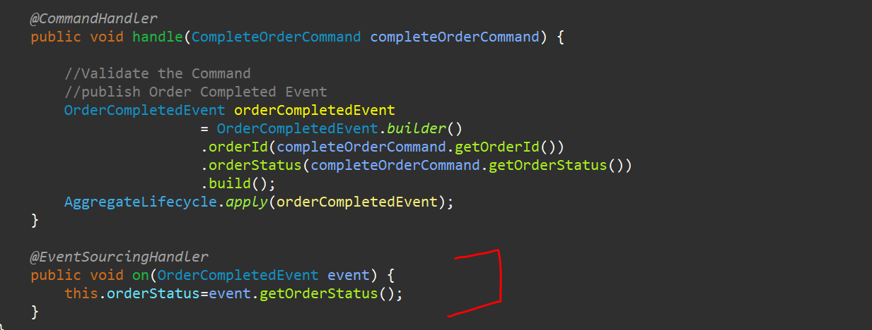

Now let’s handle this particular event in the Event Handler of Order Service we already have an event OrderCreatedEvent so let’s create the other event for OrderCompletedEvent.

**Note**: -

**You can see that everything is similar to what we are doing right? It’s just a repetition of code but we are handling it properly in event-driven-architecture. If you are doing directly in monolith then this much code no need to do It will directly just an implementation but as this is microservice and this is a distributed transaction we are doing a lot of things to handle all the failures and all the positive scenarios and all these particular things are going to stored in each and every database.so, for payment it has its own database for Shipment it has its own database so all these databases are different. The common thing that we have that holds together is our AXON Server and the Event Sourcing that we have so, that contains each and every detail which is been used to handle all these particular things.**

Now this particular event what we have to do here is we need to get the same order id and we need to update the same order and save it again.

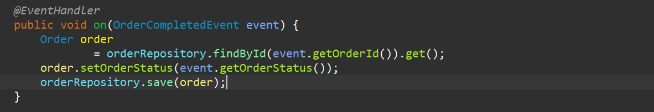

So, this particular event has been handled. Now the same event we need to handle using Saga as well.

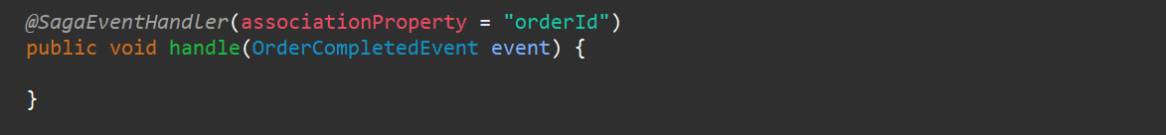

Now at this particular point if u see the diagram



You can see that it (**Order Saga**) will again send the Command to the **Notification Servic**e, but we have not created the Notification Service. if u want u can send another command to the notification service and it will send email or SMS u want to do. But u can say end of the day and we can complete the **Saga** over here. because u can see it is the same thing everywhere there is a command, and we need to handle that particular command and that particular command will publish the event and that event has to be publish. In the **Saga** also and in the similar service also to save the data and to update the data or whatever operations we need to do.

So, for now let’s end the **Saga** here. I will just annotate with **@EndSaga**. That means that particular **OrderCompletedEvent** will complete the saga for us.

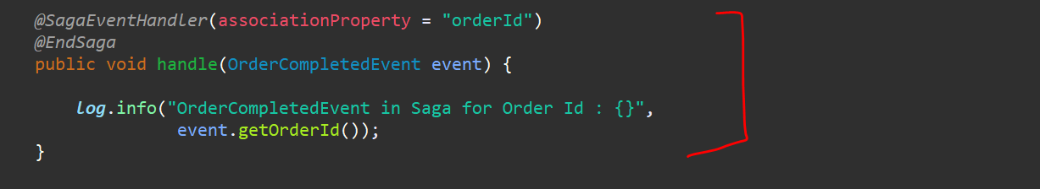

The Entire Success flow has been completed.

So, to test we can start all the particular Services and we can place one order and we can see everything is working fine.

Let’s start the Axon Server….

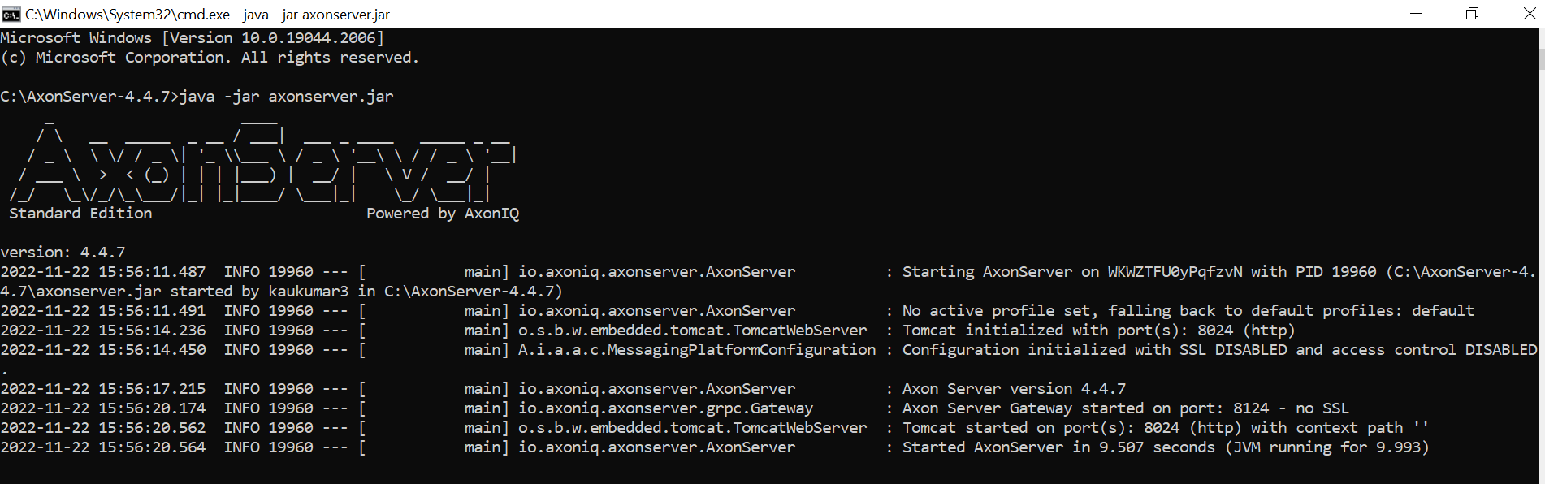

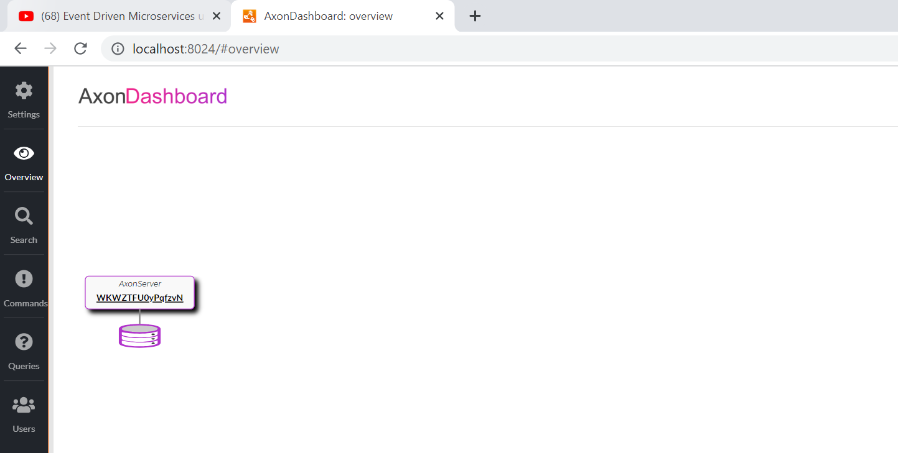

Let’s start all the 4 services ---- **OrderService**, **PaymentService**, **ShipmentService** and **UserService**.

2022-11-22 16:04:39.456 INFO 20936 --- [ main] o.s.b.a.h2.H2ConsoleAutoConfiguration : H2 console available at '/h2-console'. Database available at 'jdbc:h2:file:~/data/orderDB'

So, let’s go and open one of the API. Let’s open for the order db. Order Service running on port

<http://localhost:9091/h2-console>

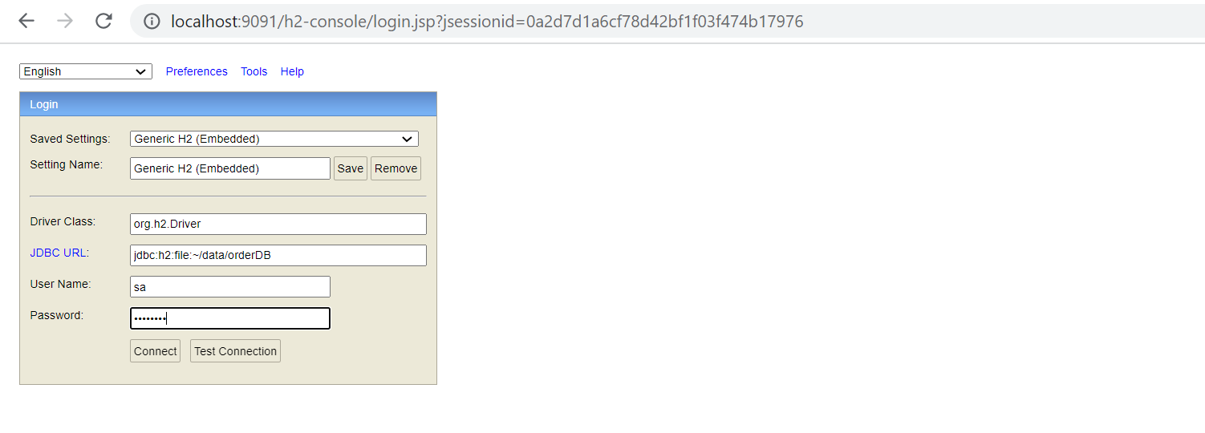

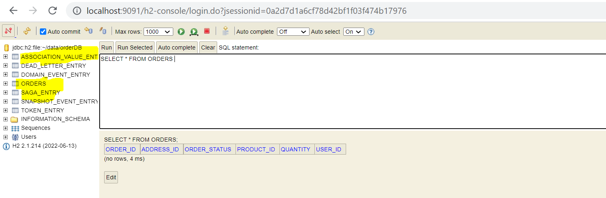

As of now there is no data presents into the OrderDB. So, we will go to the postman, and we will hit the particular URL.

If u go to the OrderService Controller u can see, we have a **POST** mapping for **/orders** over here. and for the Request body I mean postman payload we have a OrderRestModel over here.

**private String productId;**

**private String userId;**

**private String addressId;**

**private Integer quantity;**

<http://localhost:9091/orders>

{

  "productId":"24dbaca6-6a58-11ed-a1eb-0242ac120002",

  "quantity":"1",

  "addressId":"3001c2e6-6a58-11ed-a1eb-0242ac120002",

  "userId":"008"

}

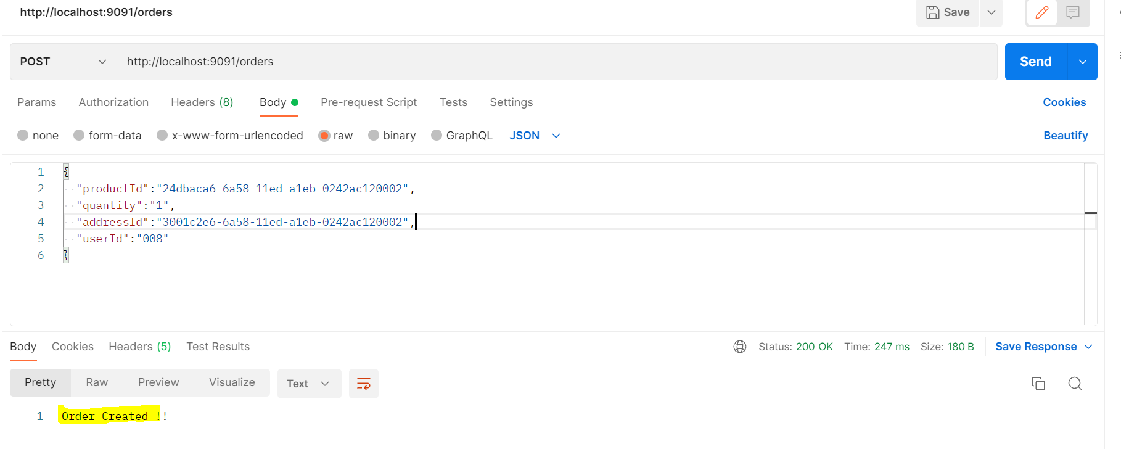

You can see that The Order is Created!! And this is the Response we sent from Order Controller.

In axon server u can see that there are 4 applications connected and the commands and events are created.

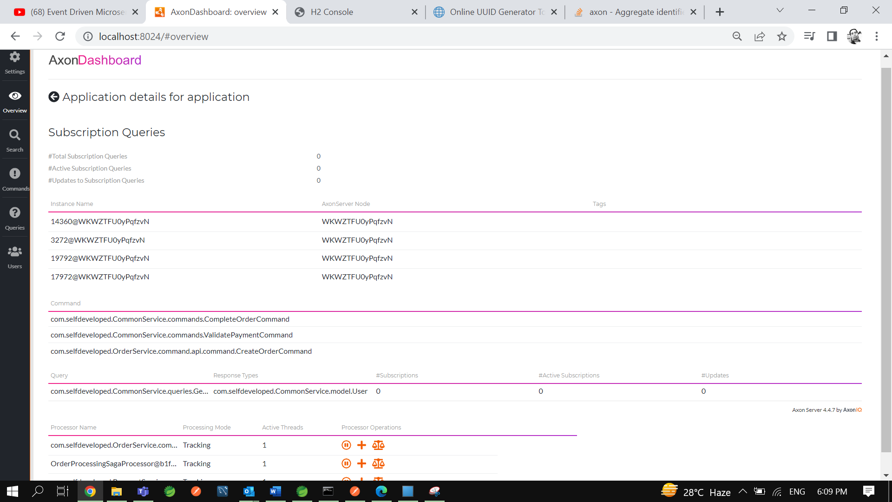

In H2 Console you can see if the order is updated.

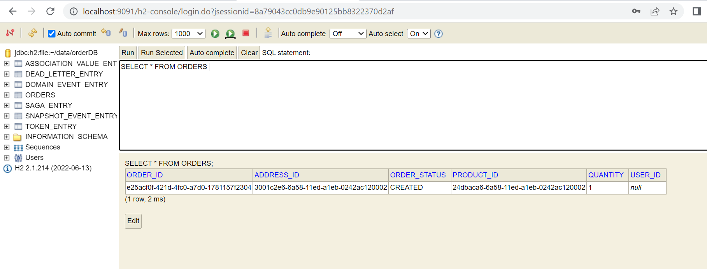

There is some issue so that Order is not Approved yet.

Let’s see what the issue is…

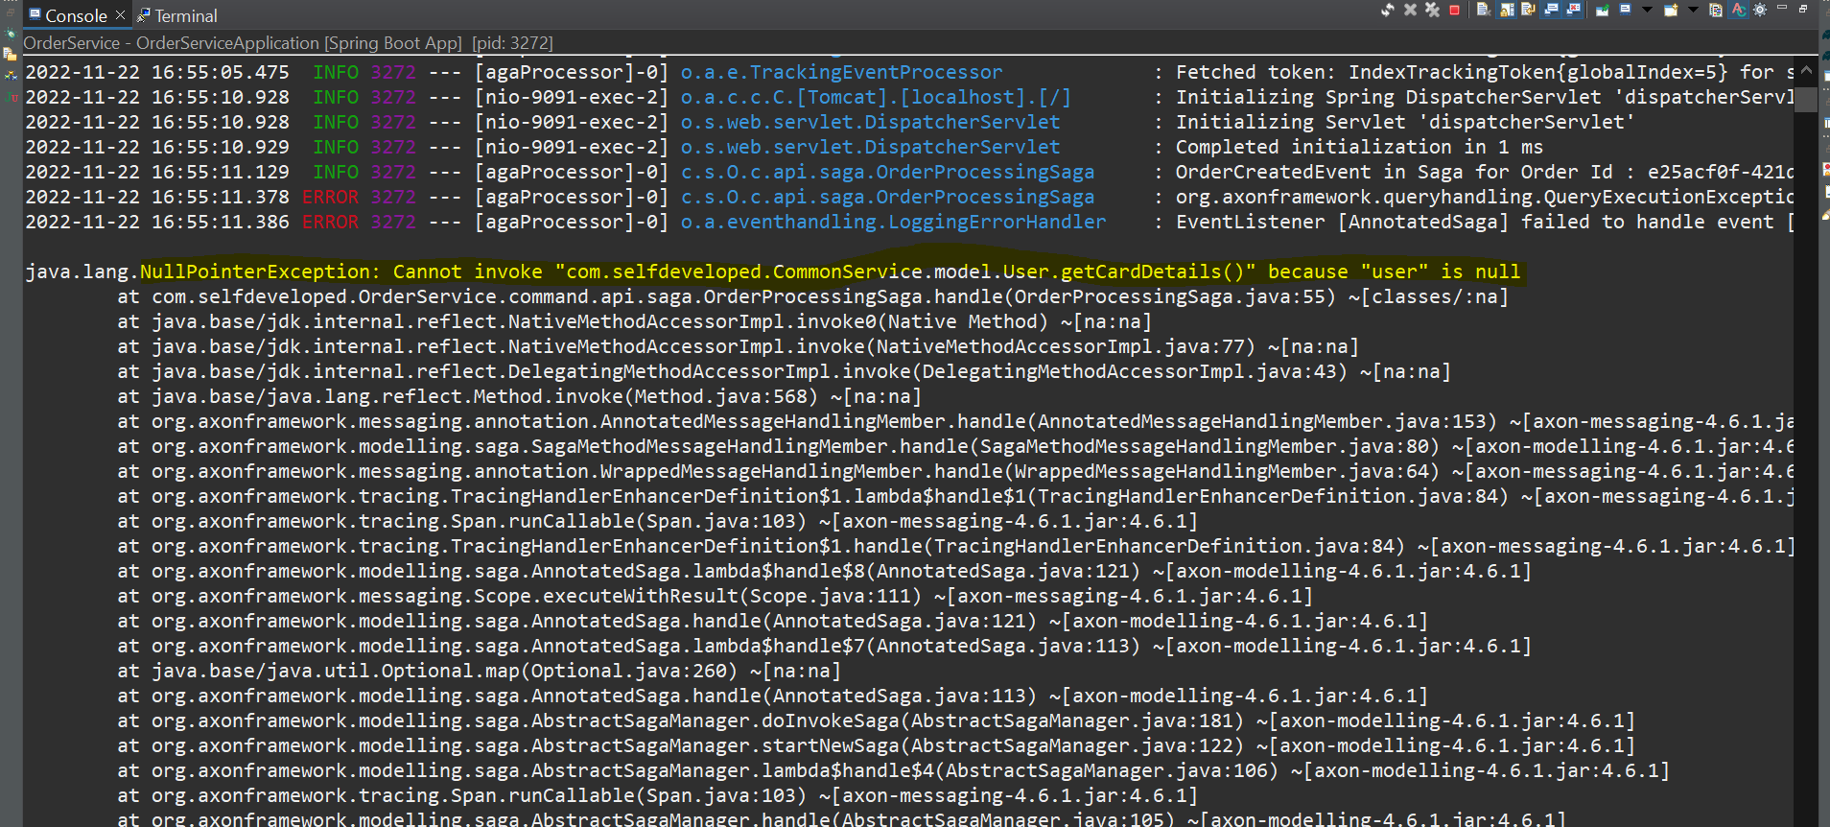

I am getting the **NullPointerException** I am not getting the CardDetails because user is null let’s go to the User Service. we have no idea about QueryHandler at this time so let’s create the controller and invoke it for query handler. Here I am taking userId as a path variable and here I will just call the particular query what we have already created using **QueryGateway**.Query that we are going to use is **GetUserPaymentDetailsQuery**.

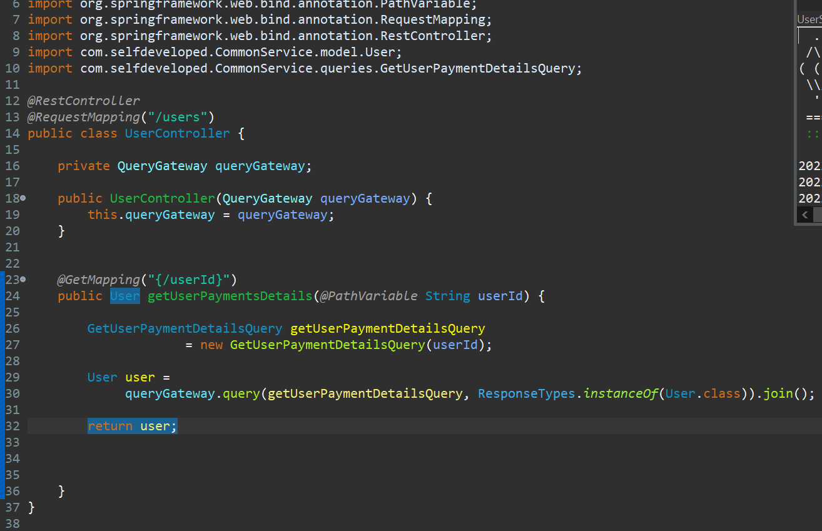

So, we will get to know these particular details either we are getting or not.

Restart this User Service. let me go to postman.

[**http://localhost:9092/users/123**](http://localhost:9092/users/123)

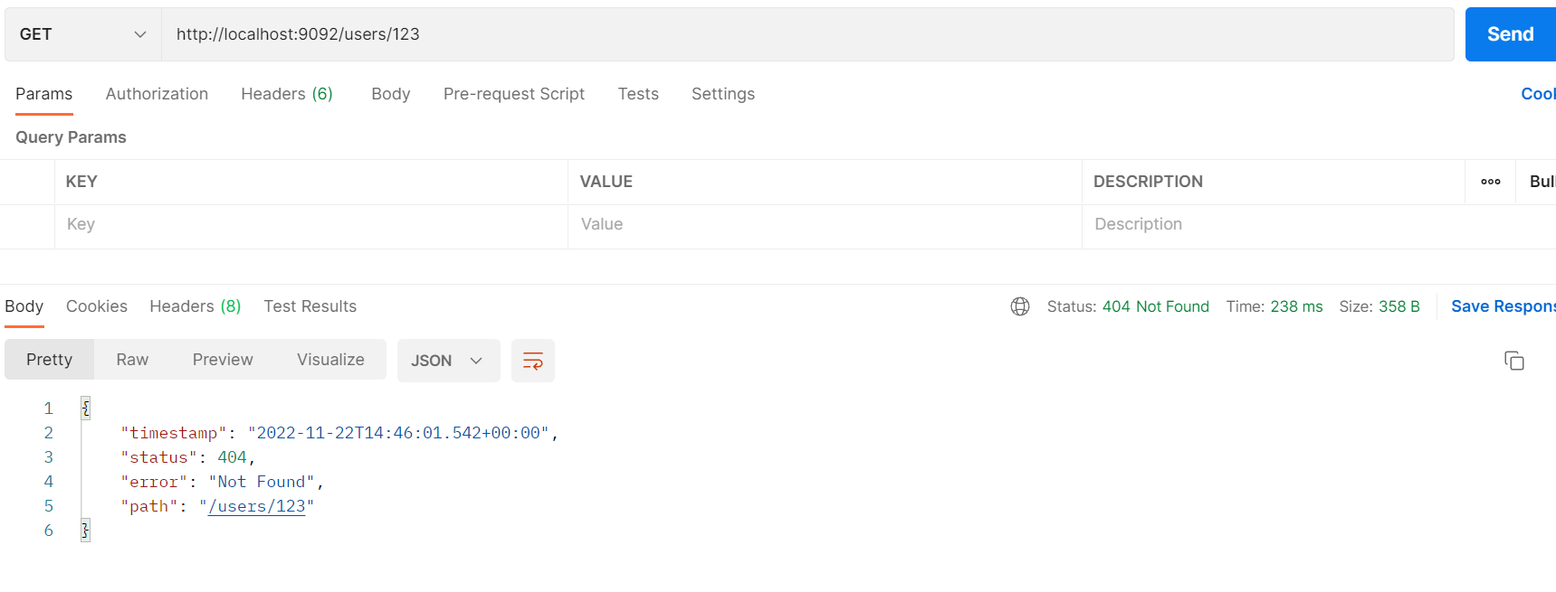

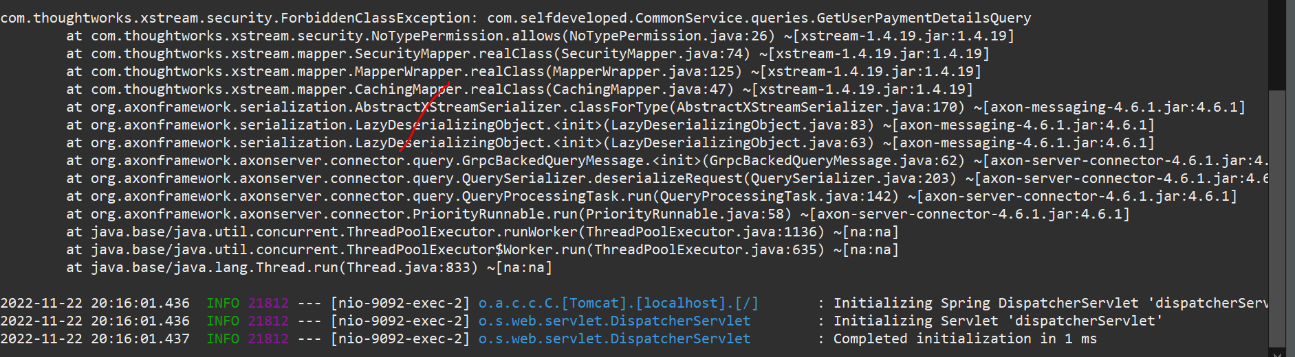

May be this would be the reason with De-Serialization…

So let me convert the CommandGateway and QueryGateway as **transient** in OrderProcessingSaga…

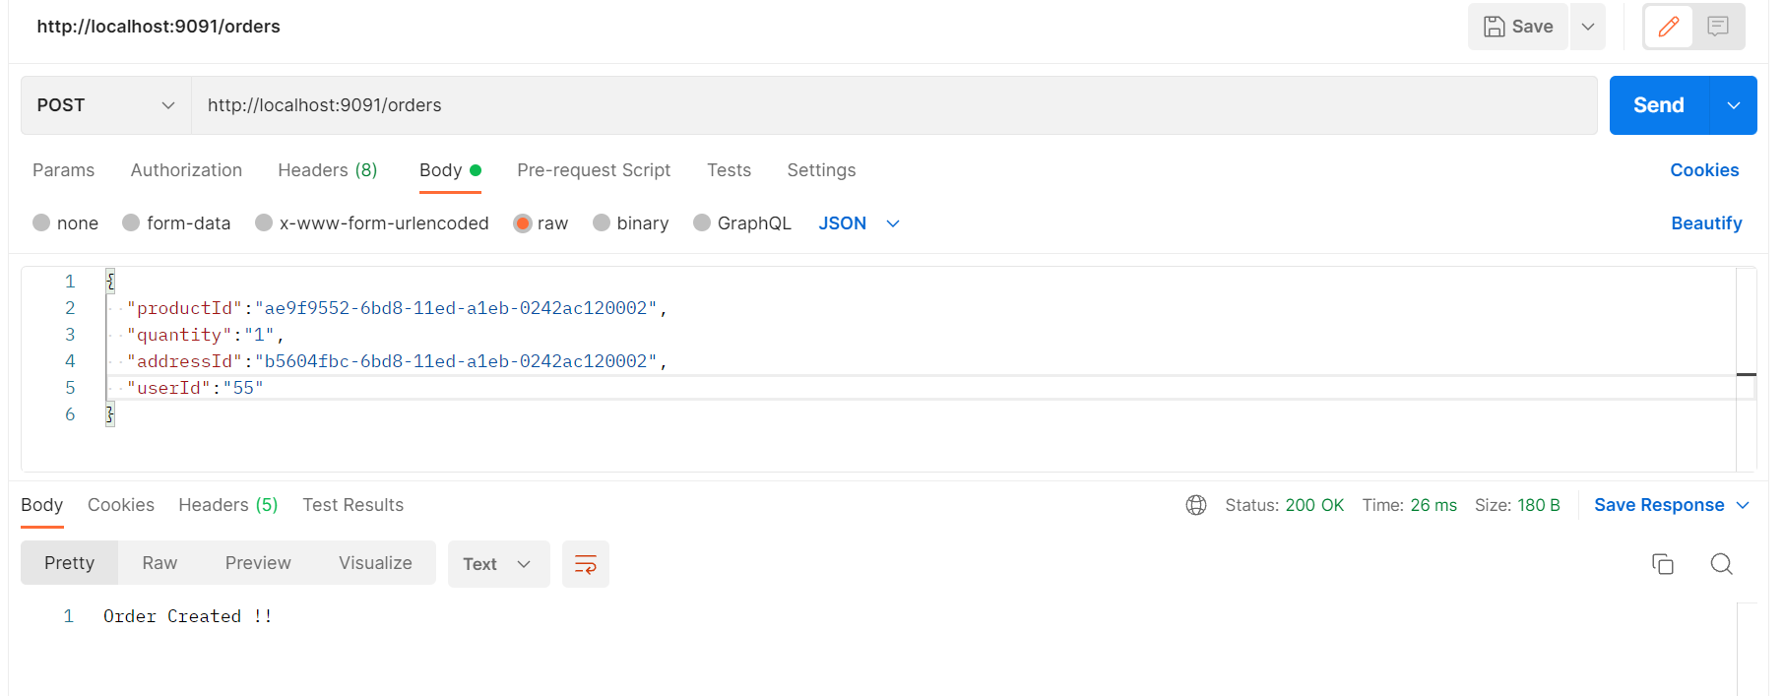

<http://localhost:8024/#overview>

All commands, Query and Events we can see on AXON Server-

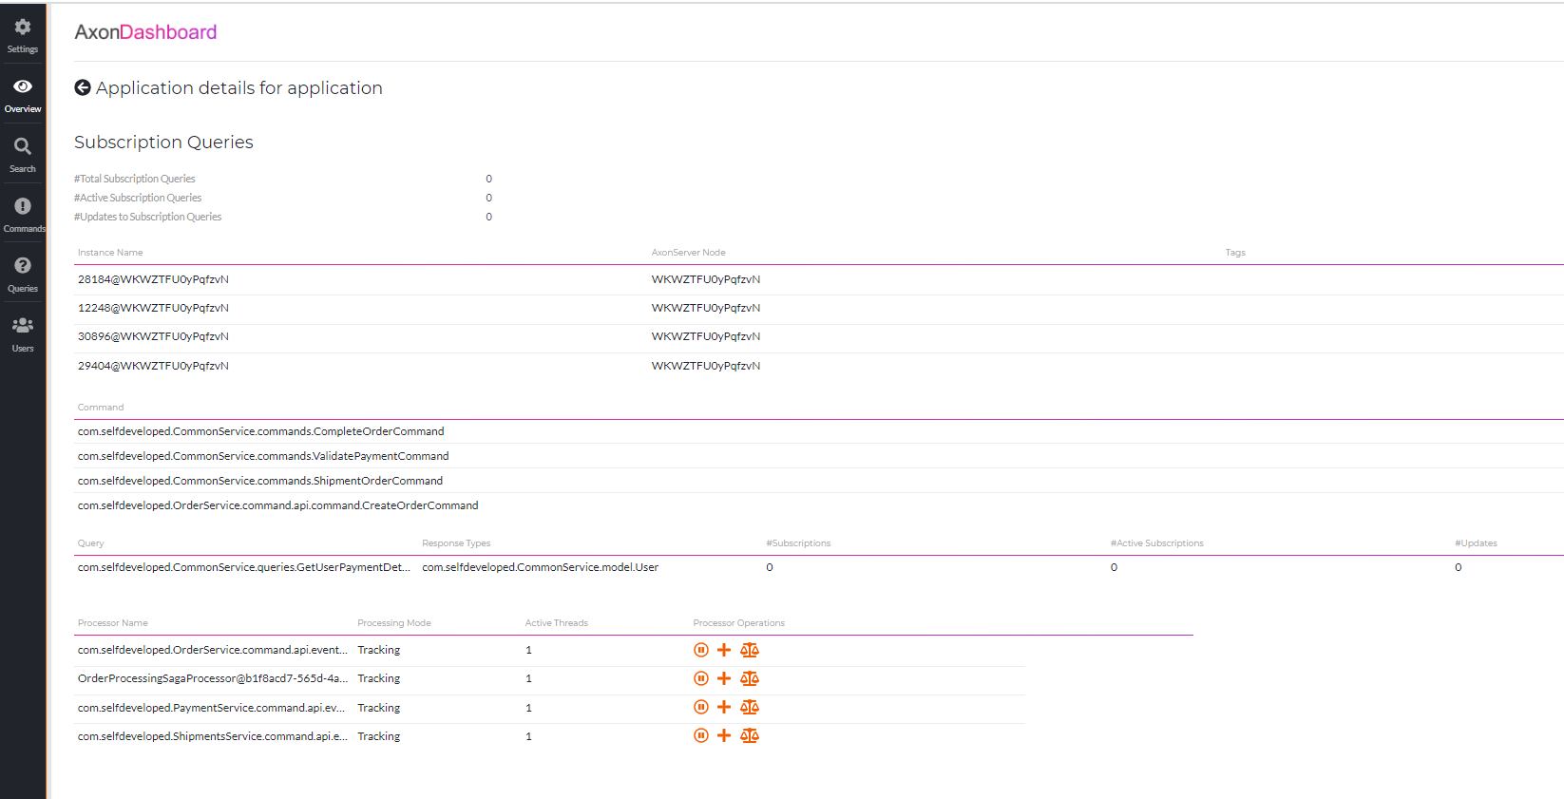

So, we can see in DB it flown end to end for positive scenario and order got APPROVED.

**Order Table-**

==========

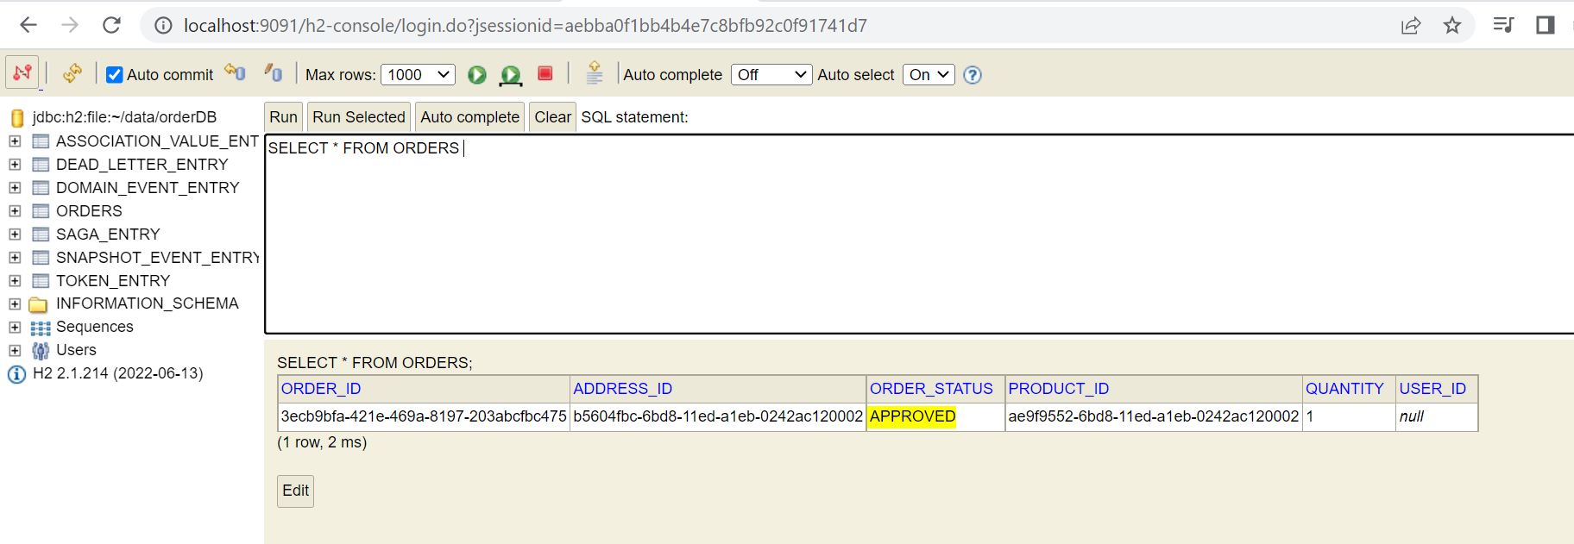

**Payment Table-**

=============

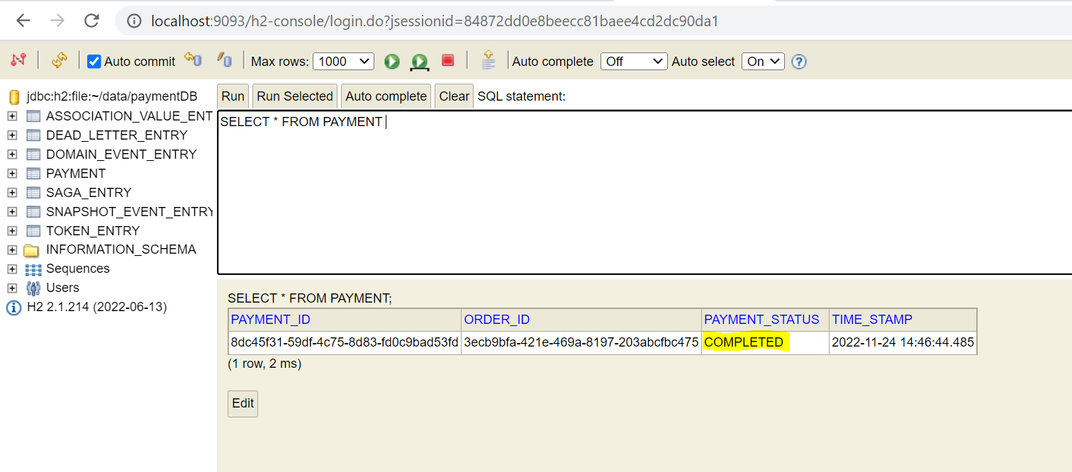

**Shipment Table-**

==============

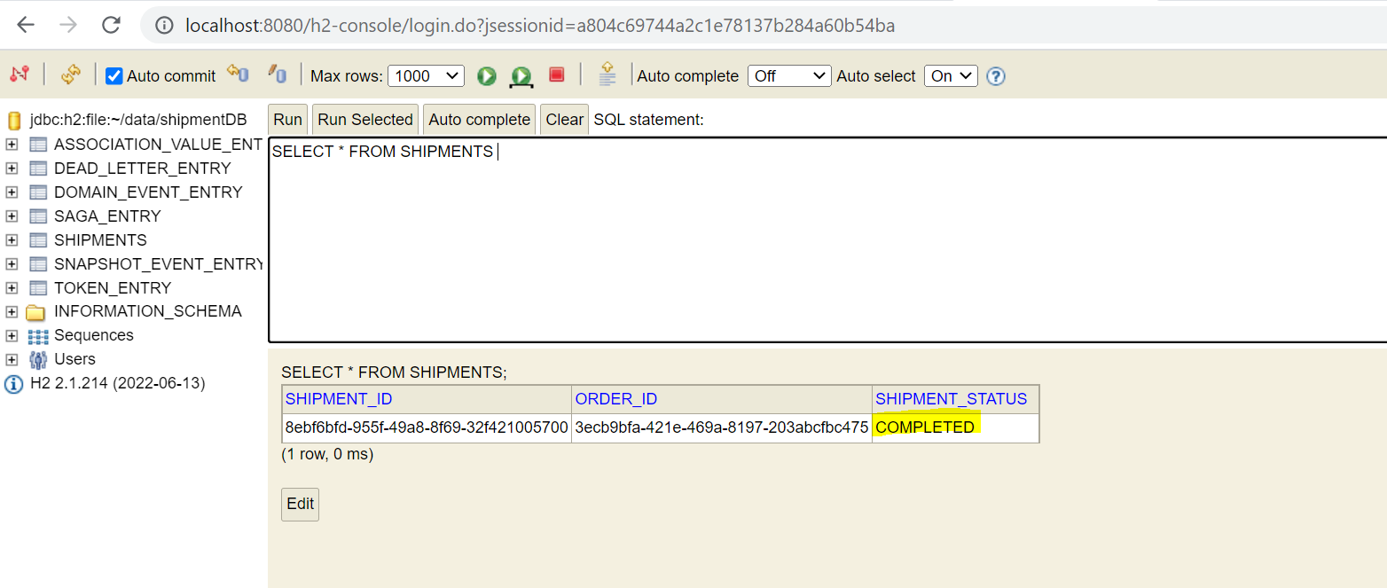

**This is the Complete Saga flow for a Success one. Now we can go and add a Compensating Transaction as well like whenever any failure occurred how to implement those Compensating transaction. So, let’s go and do that as well.**



So, here for compensating transaction we can see we have a **CancelOrderCommand** for the **CreateOrderCommand** when there is any failure in that, and we have the **CancelPaymentCommand** when there is any failure in **ValidatePaymentCommand** and so on for the **CancelShipmentCommand** as well so for now what we will do we will just implement this particular flow that is **CancelOrderCommand** and the **CancelPaymentCommand** similarly you can implement for the **CancelShipmentCommand** as well.

Let’s go to STS and let’s go to OrderProcessingSaga and we have the method that is taking **OrderCreatedEvent** as the input over here so OrderSaga handling this particular event. So here you can see we are doing some operation over here so if any error will occur, we start to do compensating transaction over here.so, at this particular point if I am not getting the user payment details then at that time there is no need to process the particular order we can cancel the particular order and if I am getting issue while sending this particular command **ValidatePaymentCommand** to the **CommandGateway** so when there is any issue with ValidatePaymentCommand so at that time also we can start compensating transaction to cancel that particular order.

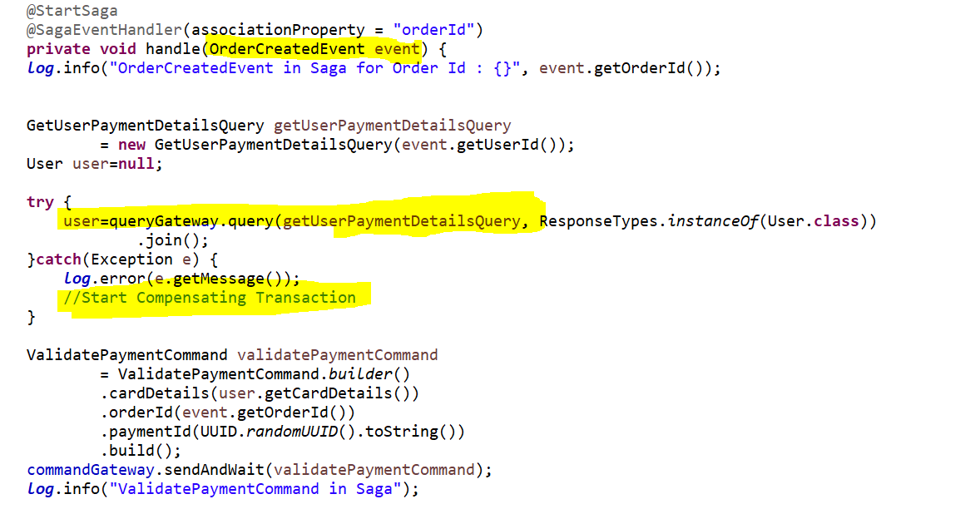

So, let’s create a method to do the compensating transaction to cancel the order.

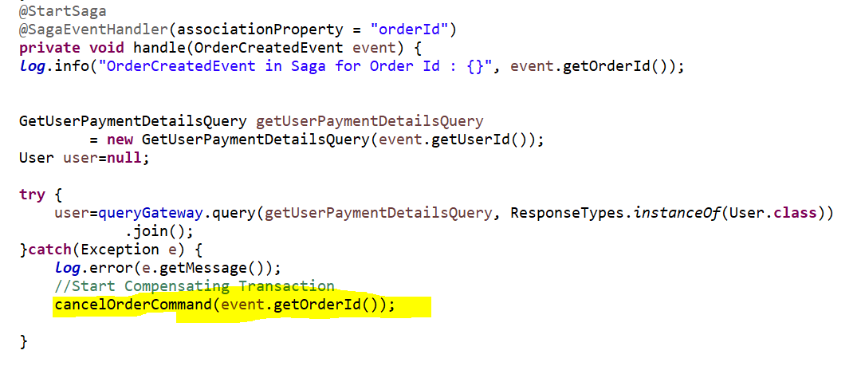

So, for that particular orderId I have created a method in same **OrderProcessingSaga** class to cancel the order or start to do the compensating transaction.

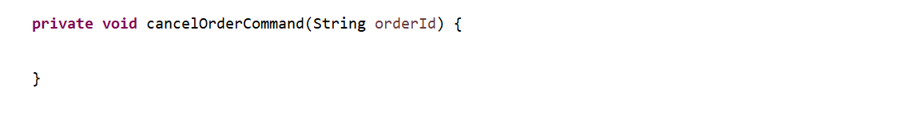

Now this particular method is used to handle the cancellation of the order. So, I need to have the **CancelOrderCommand** as well so, let’s add in the **CommonService** only.

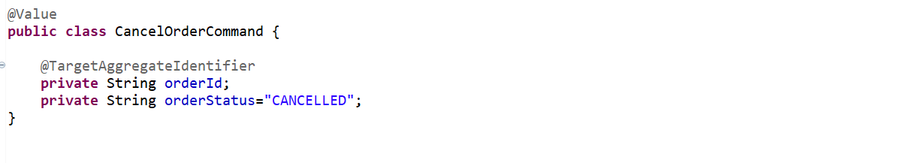

We annotated orderId as @TargetAggregateIdentifier for our Aggregate to handle this particular command

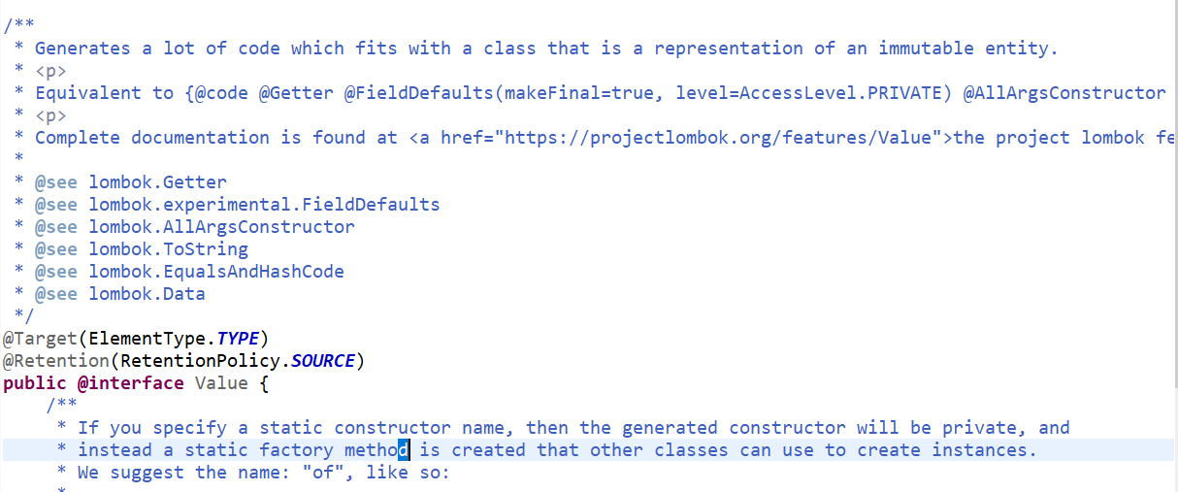

So, if u specify the @Value then it will take care for **Getter**, **AllArgsConstructor**, **ToString**, **EqualsAndHashCode**

So, to handle this particular command **CancelOrderCommand** I have to go to the **OrderAggregate** in **OrderService**. So, already there are 2 CommandHandler for **CreateOrderCommand** and **CompleteOrderCommand** let’s add one more.

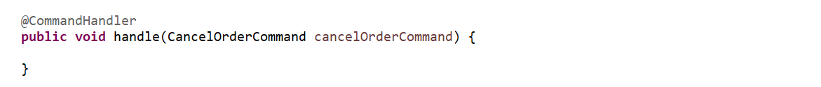

Now this particular command will result in the event that is **OrderCancelledEvent** to handle out the particular scenario. So, let’s go and create this particular event **OrderCancelledEvent** will get trigger either we can go and send the alert notification like your order is cancelled or we can end that particular saga at that particular moment as well. So, let’s create this event **OrderCancelledEvent in** **CommonService**. So for this **OrderCancelledEvent** let me add the same payload what we have added in our **CancelOrderCommand.**

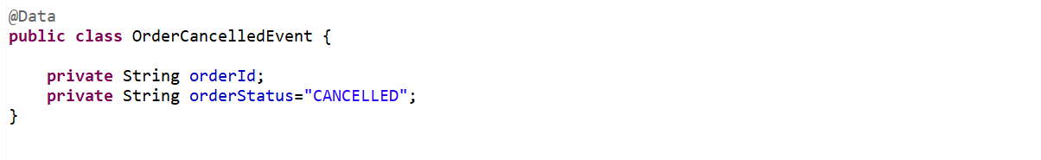

Now let’s go back to the **OrderAggregate**…

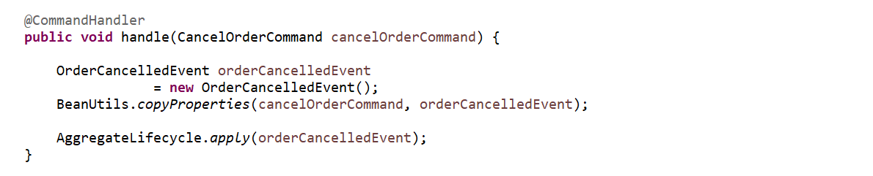

So, we are creating and publishing the event. Now for every CommandHandler whatever u are handling Aggregate we need to handle EventSourcing as well.

So, what ever the values that has been updated we need to handle that.

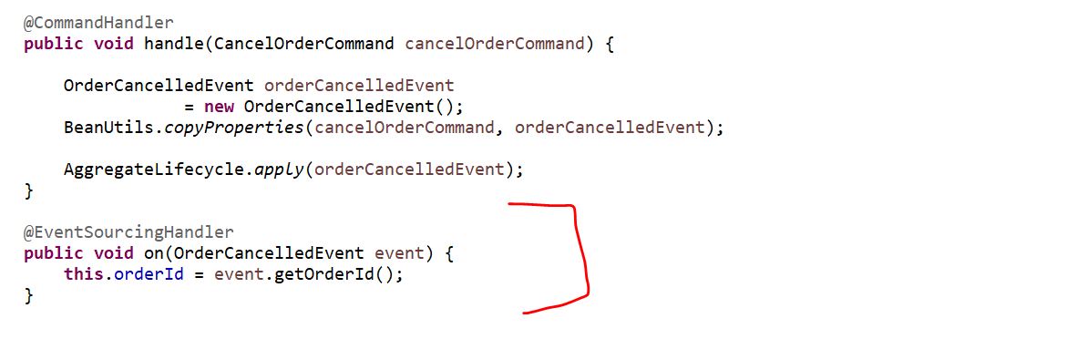

Now this particular event has to be handled at 2 places. In the OrderService to complete this particular event and update into the database as well plus in the OrderProcessingSaga as well to start the new particular command.

Now go to the OrderEventsHandler over here…

Here I want to get that particular order from the Database based on the orderId what we have, and I want to update the status of that particular order.

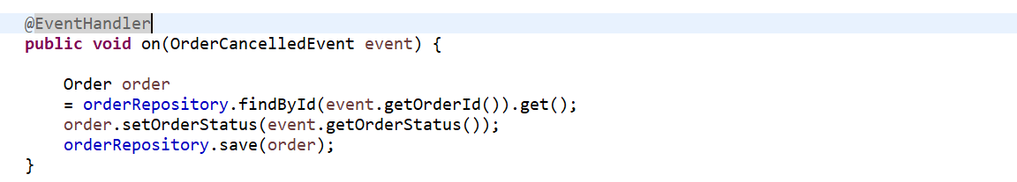

Now let’s handle this particular event in the OrderProcessingSaga. Now whatever the particular **CancelOrderCommand** we have created in OrderProcessingSaga we need to send that command to CommandGateway as well. We forget to add so let’s add that as well.



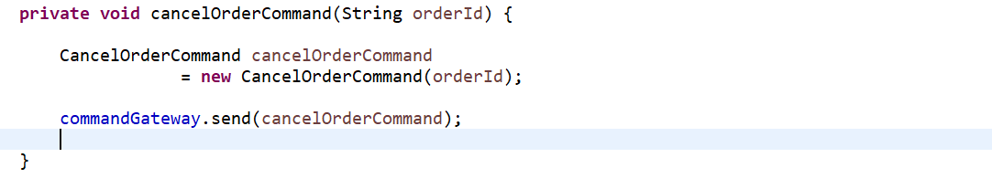

So, this particular method has been created. Now let’s handle that particular **CancelledOrderEvent**. And let’s annotate with @SagaEventHandler with association property orderId.

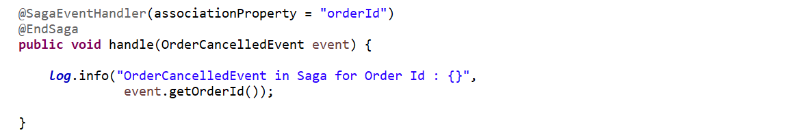

Because if u see this particular example over here this is the last event. If u want u can create one more command that is the **AlertCancellationCommand** and that will be the result in the new event to send the Alert notification but for now to understand and to make this tutorial short, I am just doing it over here. but if u want u can go and create a new command and u can handle that as well. So, this particular event will end the saga for now.



This is one thing we have implemented now the other thing was to cancel the payment as well. So, whenever there is an issue in the particular **ValidatePaymentCommand** as well at that time also we will do compensating transaction as well. So let’s do this.

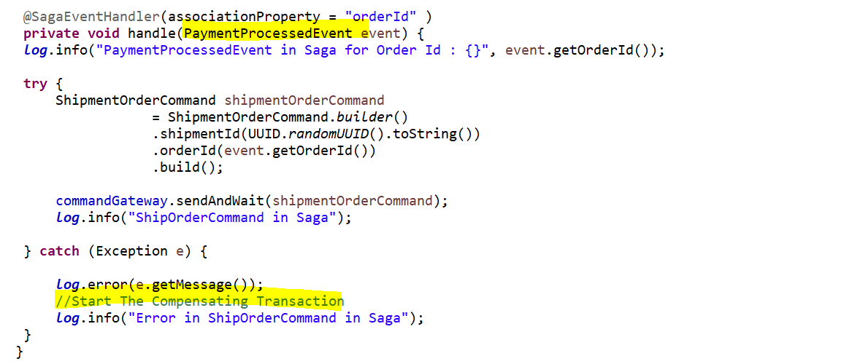

So, if u come to this particular point so u can see this particular method that is **PaymentProcessedEvent** so, whenever is there any issue with this particular PaymentProcessedEvent handler that means u need to start the compensating transaction and u need to cancel the payment. Bcz at this particular point ur payment is processed and u are going for the shipment and u got some error so, u need to cancel the payment as well and again u need to cancel the order as well.so that is ur 3 point of transaction that is ShipOrderCommand so whenever u need to do the compensating transaction for that u need to do **Cn-1** so, u need to cancel the payment plus u need to cancel ur order as well.

So, at this point whenever u got the exception for that u will create the compensating transaction for ur payment reversal.

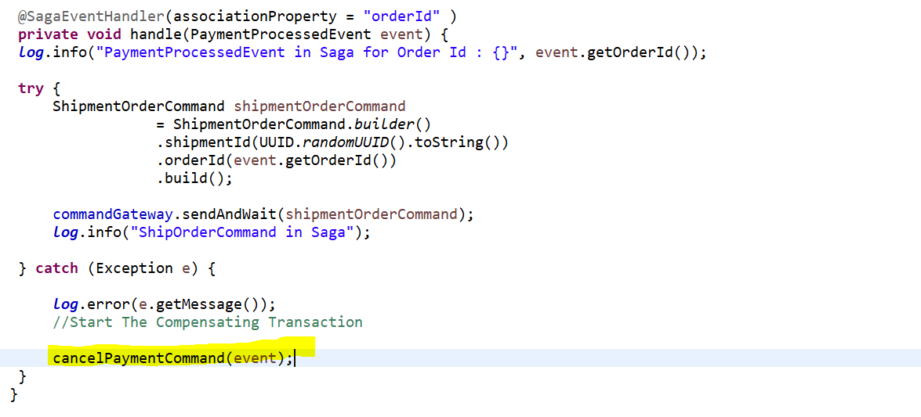

So, this method will be in OrderProcessingSaga itself.



For this let’s create a command in common service. so, that command would be **CancelPaymentCommand.**



This class will have paymentId which payment to cancel and orderId for which order and status of the payment.

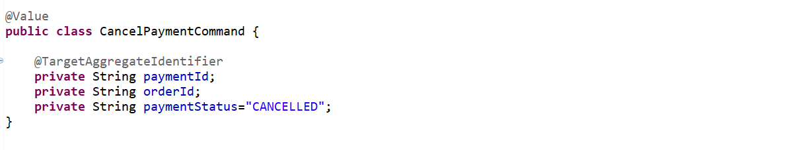

This particular command we need to send via command gateway.

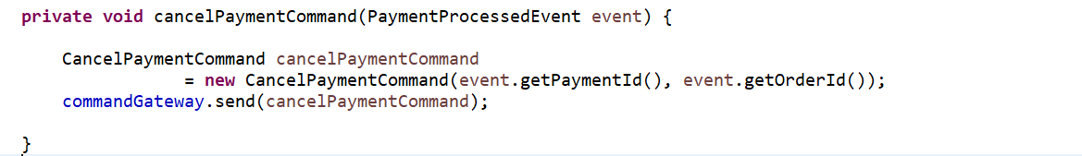

Now I need to handle this in PaymentAggregate bcz this is the part of the payment service. in this aggregate already handled ValidatePaymentCommand. We will handle one more command over here.



This particular command handler will result in the new event that is **PaymentCancelledEvent**.so let me first create in a common service.

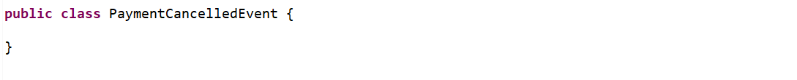

So here we will add the same payload from the **CancelPayloadCommand**.

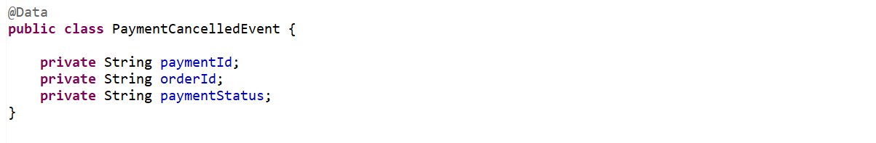

Now let’s go to payment aggregate and create the particular event.

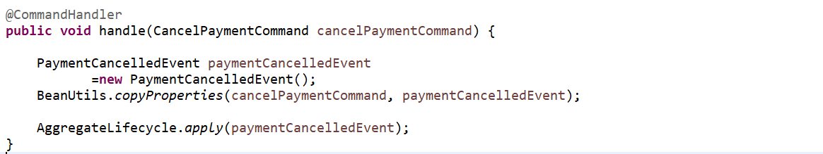

Now all the events we published we need to handle the Event Sourcing as well.

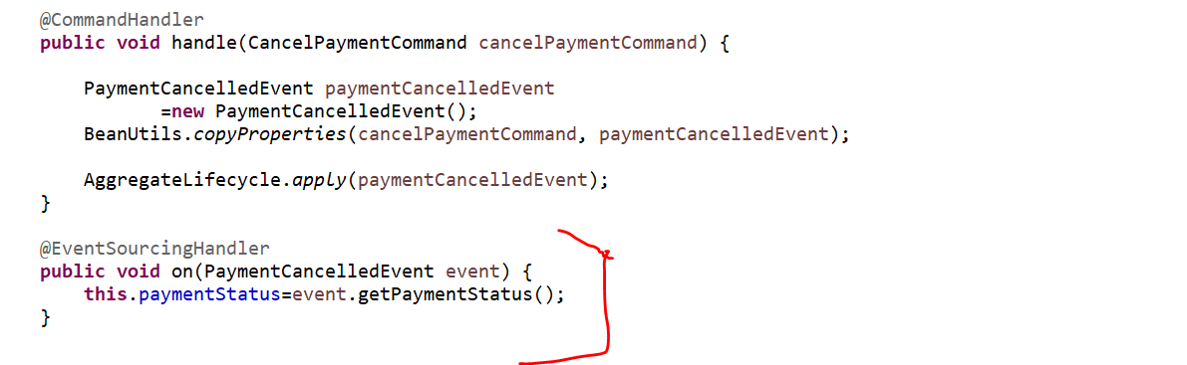

Now the event has been applied. So, this particular event has to be handled at 2 places withing the payment service in payment event handler to update the database plus, in the order processing saga to create the new command or to complete the particular transaction.

So, let’s go to PaymentsEventHandler to handle this particular event.

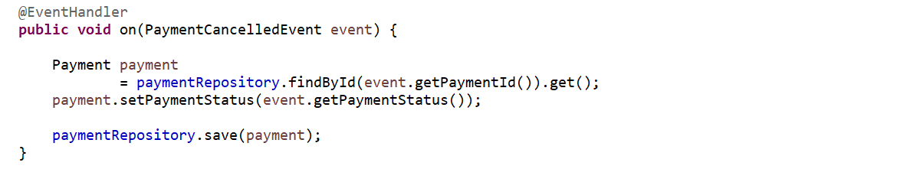

So, this particular event should be handled from the OrderProcessingSaga also.

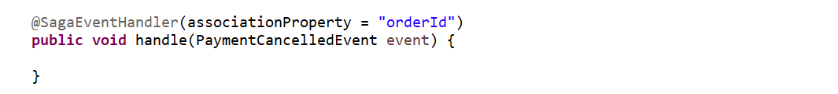



PaymentCancelledEvent will result in the cancellation of the order as well.

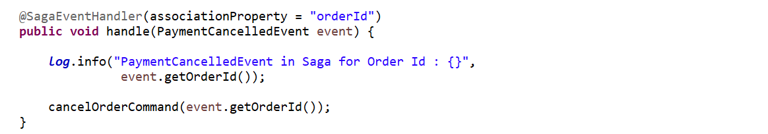

Cancelled event will be call the CancelOrderCommand and we just need to pass the order id so from the event I will get the order id and we already have this particular command method created.

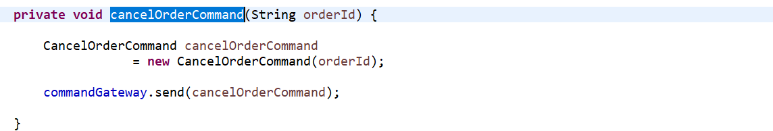

It will send this particular command and it will handle this particular event to end the saga. At this particular point OrderCancelledEvent.

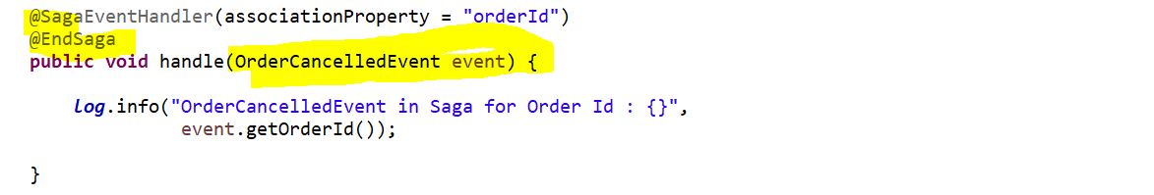

So, your entire saga will be completed over here.

The same way u can go and implement CancelShipmentCommand as well.

So, here I will make a scenario where if there is any issue in ur shipment then u need to revert ur payment plus we need to revert ur cancellation of the order as well.

So, when ur payment is being processed this particular point I will do I will throw the exception.

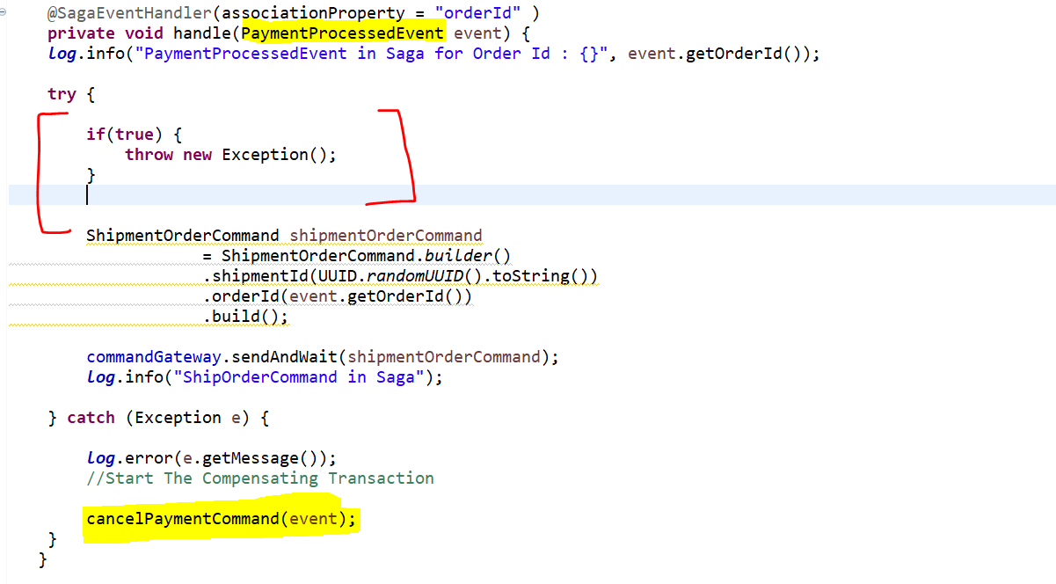

So, when ever PaymentProcessedEvent has been handled over here at this particular point some exception will occur. So, it won’t be able to handle this particular event that is **ShipOrderCommand** and it will end up in the exception that is catch block over here and it will cancel the payment for this.

Ok so let’s re-run this application and let’s test it out.

So, let’s run the axon server first.

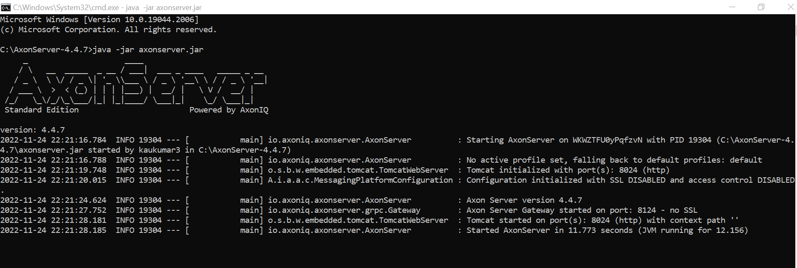

Let’s re-run all the application in sts.

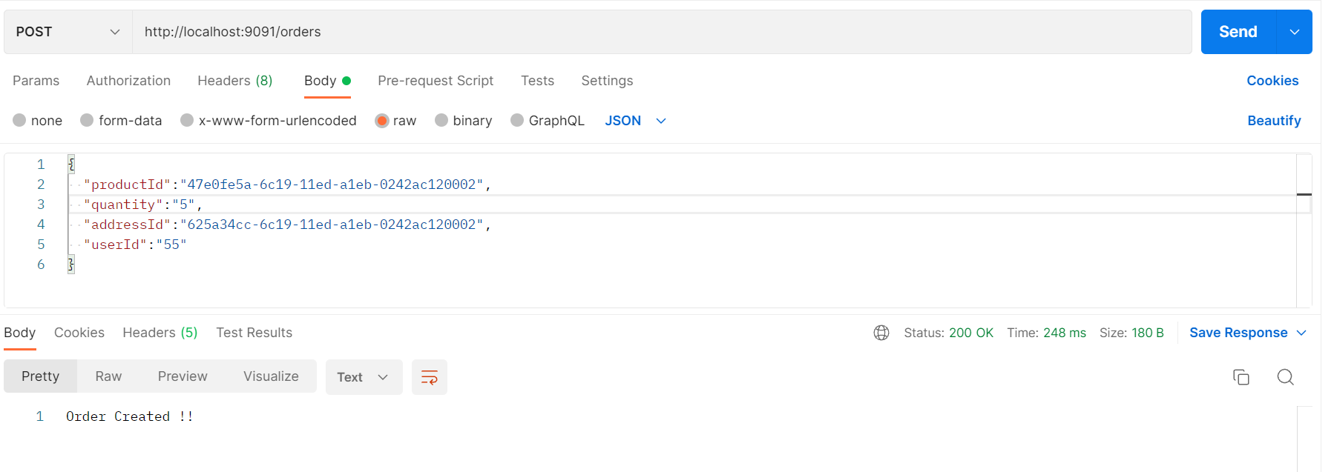

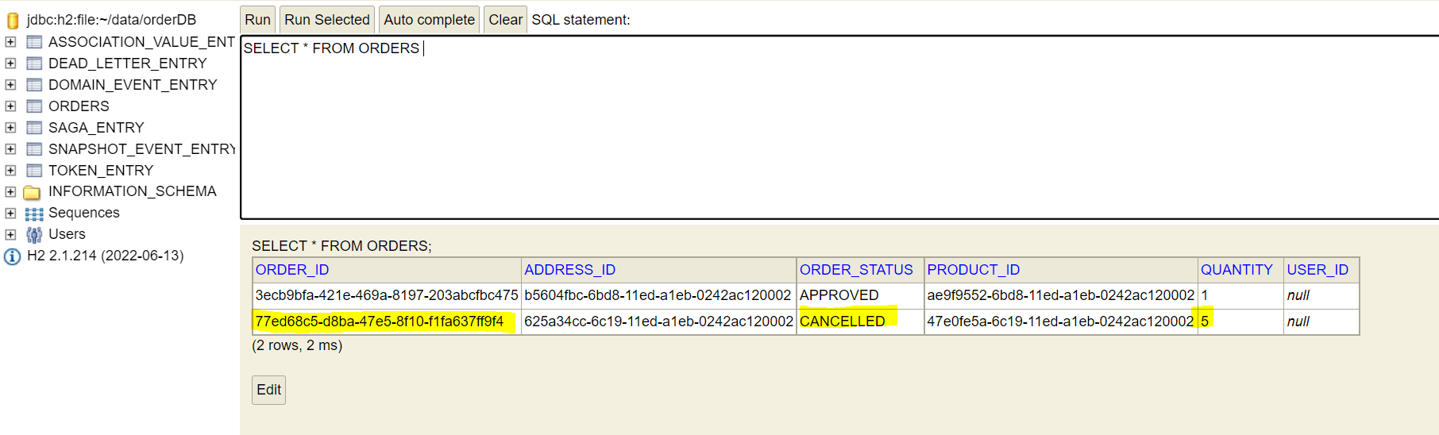

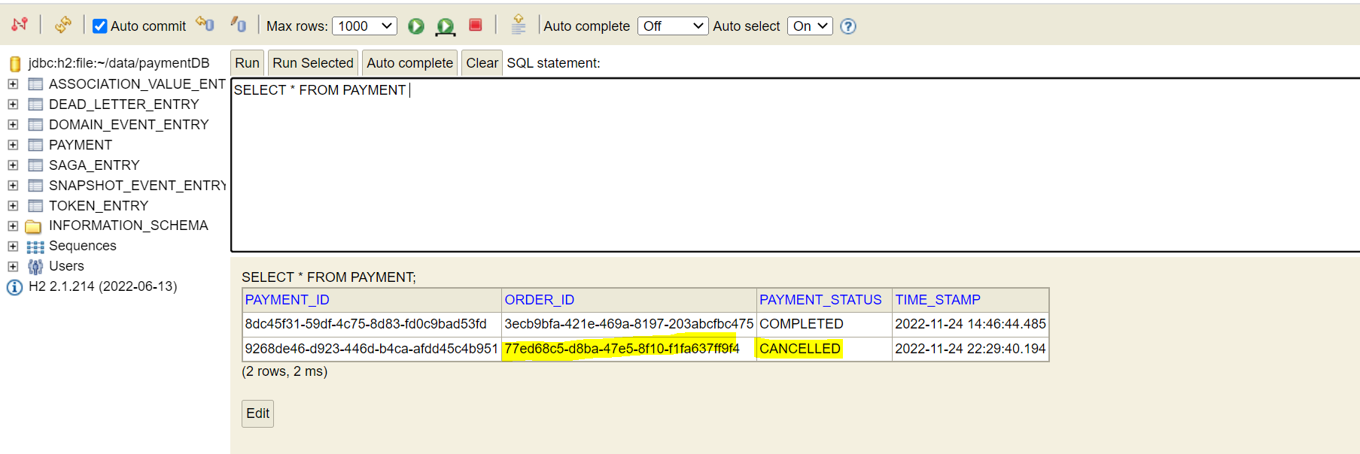

For this order id(**77ed68c5-d8ba-47e5-8f10-f1fa637ff9f4**) payment status is **CANCELLED** and order status is **CANCELLED.**

Now let’s see any other entries like Shipment happened or not.

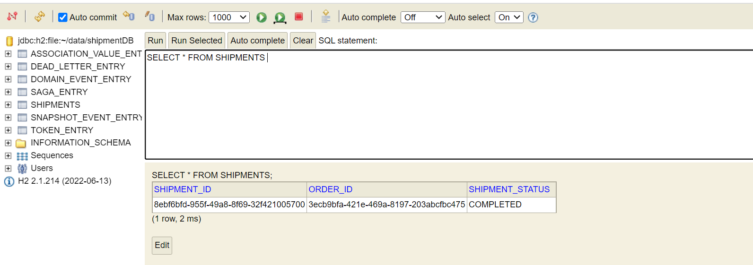

So, there is only one entry. There are no entries for order-id **77ed68c5-d8ba-47e5-8f10-f1fa637ff9f4** in the Shipment DB. That means there are some issues while doing the shipment and the entire process before that, that is the Payment and the Order Created that was Cancelled over here. So, this way you can see that we have handled the compensating transaction as well. So, whatever the steps have u done at that particular point in that Saga you can reverse everything that you have already done. So, we were at 3rd point of our transaction and at that particular point we got the error. So, we handled using this compensating transaction. We created the transaction to revert whatever was happened. So, this way u can handle the distributed transaction across the different microservices that we have using the Saga design pattern. This is the Orchestration design pattern we have seen over here. there are many more advance topics as available to handle the distributed transaction but this is the foundation of how particular transaction is been handled distributed transaction has been handled in Saga Design pattern and this is how the Event Sourcing and Event-Driven-Architecture will work.